TMCL-IDE
Revision V4.6.0 | Document Revision V4.03 • 12/24
The TMCL-IDE is an integrated development environment made for developing applications that use Trinamic modules and chips. It contains a set of tools for easily setting parameters, for visualizing measured data and for developing and debugging stand-alone applications with TMCL™, the Trinamic Motion Control Language.
From version 4 on, the TMCL-IDE can also use the CANopen protocol. This makes it possible to control and explore also Trinamic modules that are equipped with CANopen firmware, just using the same tools.
The TMCL-IDE is available free of charge and runs on Windows 7, Windows 8.x, Windows 10 and Windows 11. A version for Linux is also available free of charge.
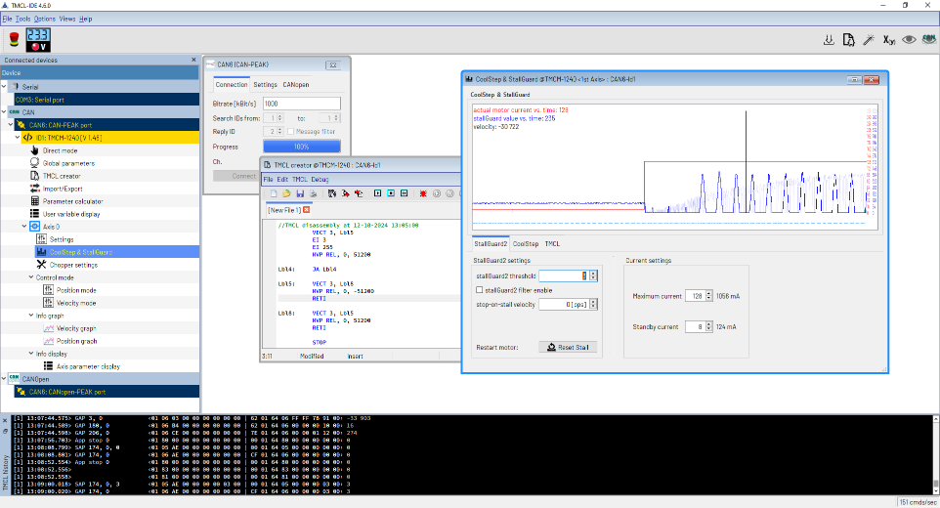
Contents
1 Introduction 4
1.1 Getting the TMCL-IDE 4
1.2 Installing the TMCL-IDE 4
1.2.1 Windows 4
1.2.2 Linux 4
1.3 Supported Interfaces 4
1.4 Launching the TMCL-IDE 4
1.5 General conventions 4
1.5.1 Number representation 4
1.5.2 Entering values 4
2 The Main Window 4
2.1 Menu Bar and Status Bar 5
2.2 Tool Bar 5
2.3 Device with Tool Tree 6
3 Connections 6
3.1 USB 7
3.1.1 Connection 7
3.1.2 Settings 7
3.2 RS485 / RS232 8
3.2.1 Connection 8
3.2.2 Settings 8
3.3 CAN 9
3.3.1 Connection 10
3.3.2 Settings 10
3.3.3 Hints for Peak CAN Interfaces 10
4 Module specific Tools 10
4.1 The Main Module Tool 11
4.2 The Direct Mode 11
4.3 The Global Parameters Tool 12
4.4 The TMCL Creator 12
4.4.1 The File Menu 12
4.4.2 The Edit Menu 13
4.4.3 The TMCL Menu 13
4.4.3.3 Run 13
4.4.3.4 Stop 13
4.4.3.7 Options 14
4.4.4 The Debugger 15
4.4.5 Breakpoints 15
4.4.6 The Run/Continue Function 15
4.4.7 The Pause Function 15
4.4.8 The Step Function 15
4.4.9 The Animate Function 16
4.4.10 The Stop & Reset Function 16
4.5 The Import/Export Tool 16
4.6 The Parameter Calculator 16
4.6.1 TMC429 based Stepper Motor Modules 16
4.6.2 Stepper Motor Modules that use pps Units 17
4.7 The User Variable Display 17
4.8 The Settings Tool (Stepper Motor) 18
4.9 The Closed Loop Tool 18
4.10 The Chopper Settings 19
4.10.1 The Thresholds Tab 19
4.10.2 The StealthChop Tab 19
4.10.3 The SpreadCycle Tab 19
4.10.4 The High Speed Tab 20
4.10.5 The TMCL Tab 20
4.11 The Velocity Graph 20
4.11.1 Selecting Parameters to be displayed 21
4.11.2 Other Options 21
4.12 The Position Graph 22
4.13 The Torque Graph 22
4.14 The Velocity Mode 22
4.15 The Position Mode 23
4.16 The Torque Mode (Stepper Motor) 23
4.17 The Torque Mode (BLDC Motor) 23
4.18 The Axis Parameter Display 24
4.19 The StallGuard Adjuster 24
4.20 The StallGuard Profiler 25
4.20.1 The Result of the StallGuard Profiler 25
4.20.2 Interpreting the Result 26
4.21 The CoolStep & StallGuard2 Tool 26
4.21.1 The StallGuard2 Tab 26
4.21.2 The CoolStep Tab 27
4.21.3 The TMCL Tab 27
4.22 The Settings Tool (BLDC Motor) 28
4.23 The Flags Tool (BLDC Motor) 28
4.24 The Parameter Display 28
4.25 The Parameter Browser 29
4.26 PI tuning tool 29
4.26.1 Torque tuning 29
4.26.1.1 Auto tuning 30
4.26.1.2 Manual tuning 30
4.26.2 Velocity tuning 30
4.26.2.1 Auto tuning 31
4.26.2.2 Manual tuning 31
4.26.3 Position tuning 31
4.26.3.1 Auto Tuning 32
4.26.3.2 Manual tuning 32
5 Evaluation Board specific Tools 32
5.1 The Main Evaluation Board Tool 33
5.1.1 Board Assignment 33
5.1.2 Settings 33
5.1.3 Diagnostics 33
5.2 The Register Browser 33
5.2.1 Register List 33
5.2.2 Active Registers 34
5.2.3 Utilities 34
5.3 The Flags View 34
5.4 The Chip-Click Tool 35
5.5 The Datagram Mode 35
6 Container Tools 35
6.1 The TMCL/PC Host 36
6.1.1 The File Menu 36
6.1.2 The Edit Menu 36
6.1.3 The TMCL/PC Menu 37
6.1.4 Breakpoints 37
6.1.5 Assembler and Debugger Options 37
6.1.6 Module Assignments 38
6.1.7 The Local Variables Window 38
6.2 The Firmware Update Tool 39
6.2.1 Select Module 39
6.2.2 Select Firmware 39
6.2.3 Update Firmware 39
6.2.4 Hints for Firmware Updates 39
7 Wizards 40
8 The Syntax of TMCL 40
8.1 Assembler Directives 40
Example 40
8.2 Symbolic Constants 40
Example 41
8.3 Constant Expressions 41
Example 42
8.4 Labels 42
Example 42
8.5 Comments 42
8.6 TMCL Commands 42
9 The Syntax of TMCL/PC 42
9.1 Module Index Parameter 42
9.2 Module Index Definition 43
9.3 Local Commands 43
9.4 Local Variables 44
9.5 Evaluation Board Commands 44
10 CANopen 44
10.1 CANopen Connection 45
10.1.1 Connection 45
10.1.2 NMT 45
10.1.3 Settings 45
10.1.4 LSS 46
10.1.5 Trace 47
10.2 EDS Files 47
10.2.1 About EDS Files 47
10.2.2 EDS Files for Trinamic Modules 47
10.2.3 Integrating EDS Files into the TMCL-IDE 47
10.3 Device specific Tools 47
10.4 The Main Module Tool 47
10.4.1 General 47
10.4.2 File Info 48
10.4.3 EMCY 48
10.5 The Object Browser 48
10.6 CiA-402 State Machine 48
10.7 CiA-402 Profile Position Mode 49
10.8 CiA-402 Profile Velocity Mode 49
10.9 CiA-402 Homing Mode 50
10.10 Parameter Save/Restore 50
10.11 PDO Receiver 51
10.12 PDO Transmitter 52
10.13 PDO Configurator 52
10.14 Device Configuration 54
10.14.1 Generating DCF Files 54
10.14.2 Using DCF Files 54
10.14.3 DCF Value Overview 54
10.15 Import/Export 55
10.15.1 Generating DCF Files 55
10.15.2 Using DCF Files 55
10.16 Expert Mode 55
10.17 Velocity Graph 56
10.18 Position Graph 56
10.19 Torque Graph 56
10.20 Parameter Display 56
11 Figures Index 56
12 Tables Index 57
13 Supplemental Directives 58
13.1 Producer Information 58
13.2 Copyright 58
13.3 Trademark Designations and Symbols 58
13.4 Target User 58
13.5 Disclaimer: Life Support Systems 58
13.6 Disclaimer: Intended Use 58
13.7 Collateral Documents and Tools 58
14 Revision History 59
14.1 Software Revision 59
14.2 Document Revision 59

1 Introduction

1.1 Getting the TMCL-IDE
The TMCL-IDE can be downloaded free of charge from software section of the ADI website:
www.analog.com. The latest version can always be found there. Also older versions can be downloaded from there if needed.

1.2 Installing the TMCL-IDE

1.2.1 Windows
It is possible to download a version with automated installation. After downloading this file, just double click it to start the installation process.

1.2.2 Linux
There is also a Linux version of the TMCL-IDE with automated installation. After downloading the installation file (TMCL-IDE-Linux-x64-4.6.0.bin), run this file from the shell by entering ./TMCL-IDE-Linux-x64-4.6.0.bin to start the installation process.

1.3 Supported Interfaces
For connecting to a Trinamic module or to a Trinamic evaluation board, different interfaces can be used. These are USB, RS232, RS485 and CAN. Each module or evaluation board that is equipped with a USB interface can be connected directly via USB. It is then automatically recognized by the TMCL-IDE. For modules equipped with RS232 or RS485 interface, an appropriate interface is also needed on the PC. Many standard off-the-shelf RS232 and RS485 interfaces can be used.
For connecting via CAN bus a CAN interface that is supported by the IDE is needed. Table 1 and table 2 show all currently supported CAN interfaces. The same interfaces can also be used for CANopen connections.

1.4 Launching the TMCL-IDE
On Windows, run the TMCL-IDE simply by choosing the TMCL-IDE entry from the start menu or by double clicking the TMCL-IDE desktop icon or (mainly if you are using the non-install version) by double clicking the TMCL-IDE.exe file.
On Linux, run the TMCL-IDE.sh script either from the command line or by clicking on it. Depending on the Linux distribution and on the used interface (especially when using a CAN interface) it may be necessary to run the TMCL-IDE with administrator rights. Either, use the sudo command (sudo TMCL-IDE.sh), or use the su command before launching the TMCL-IDE. On older Linux distributions it may be necessary to prevent the modem manager from controlling the COM ports where the Trinamic modules are connected to. The easiest way to do this is to purge the modem manager using sudo apt-get purge modem manager.

1.5 General conventions
Here are some general conventions that apply throughout the entire TMCM-IDE.

1.5.1 Number representation
The TMCL-IDE uses hexadecimal and decimal numbers. Hexadecimal numbers are always shown preceded by “0x”, like in C language.

1.5.2 Entering values
In some cases, numbers can be entered as decimal numbers or as hexadecimal numbers. Enter hexadecimal numbers preceded by “0x”, like in C language. Negative decimal numbers are entered with a preceding “-” sign.
Some input fields will turn yellow when a new value is being entered. This means that the value entered will be written to the corresponding object by pressing the Return key or the Enter key. It is also possible to write out the same value again just by pressing the Return key or the Enter key once again.

2 The Main Window
After launching the TMCL-IDE the main window appears on the screen. The main window contains the following parts:
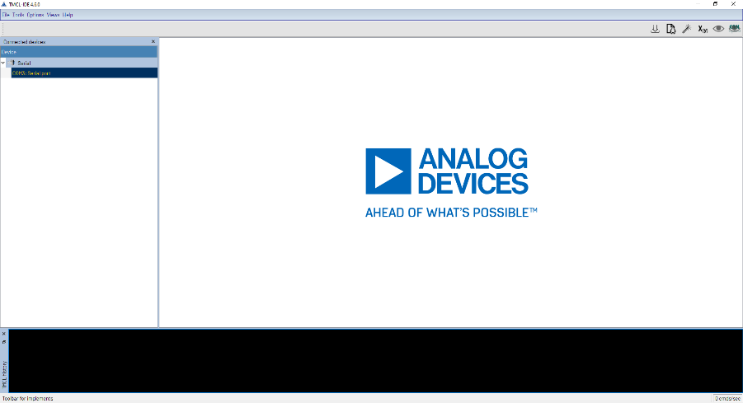
Figure 1: The TMCL-IDE Main Window

2.1 Menu Bar and Status Bar
The menu bar is placed at the top of the main window, the status bar is placed to the bottom. Both bars are not moveable.
Figure 2: The Menu an Status Bar
The status bar shows on the left side actual messages and on the right side the current TMCL command rate, which means the number of requests plus replies per second. The menu commands are sorted in five entries:
- File: Shortcut ’alt gr + p’ allows shot of actual tool window as png file and to clipboard.
- Tools: Call container tools.
- Options: Properties of tool windows moving or behavior.
- Views: Hide or show the other windows around the central view.
- Help: Visit TRINAMIC YouTube channel, show some system info, open this document or looking for updates.
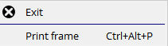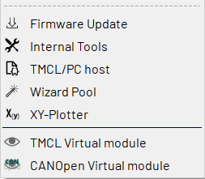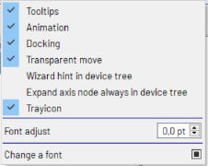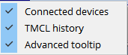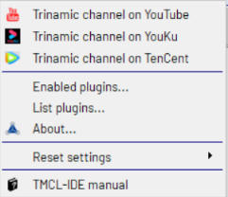
Figure 3: The Menu Bar’s entries
The about box gives an overview of the paths where components are installed. An INI file is used to store all settings and is located in home path shown. The working directory is the user’s temporary path plus TMCL-IDE. Some components are generating logging messages to the file debug.log. You can click on the link at the bottom to open this file with your system editor to view and save the content.
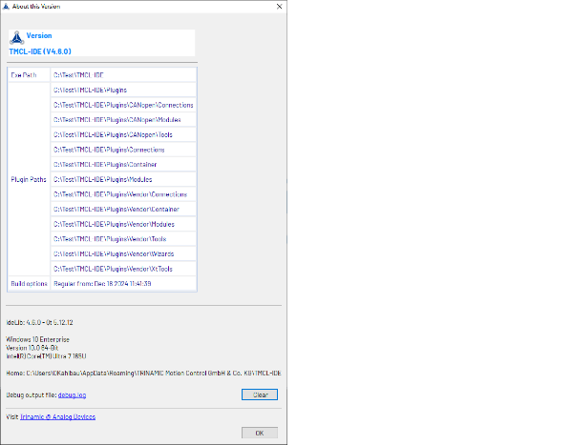
Figure 4: The TMCL-IDE About Box

2.2 Tool Bar
Here you can find most needed common tools like firmware update tool, TMCL-PC Host or the compilation of several wizards. Those are the same as menu bar’s tools. In the right corner you can get by clicking the icon to open a list of all modules, You can choose any existing module to the related tools

Figure 5: The TMCL-IDE Tool Bar
Clicking on will call the Firmware Update Tool. Flash a given firmware file to the module.
Clicking on will call the TMCL/PC Host. This tool enables writing TMCL instructions for controlling between various modules and their axes.
Call Wizards with . In the wizard tool you can pick a module to have a collection of available wizards.
The X/Y plotter plots up to four value pairs in an XY graph. Mix any values from any axes from any module.

2.3 Device with Tool Tree
The tree root entries represent the families of various serial physical interfaces: USB, serial communications port, CAN and also non-physical virtual modules. Each root entry contains the connected interfaces and each interface is the parent of one or more connected TMC Module. Each module is the parent of tools depending of its characteristics.
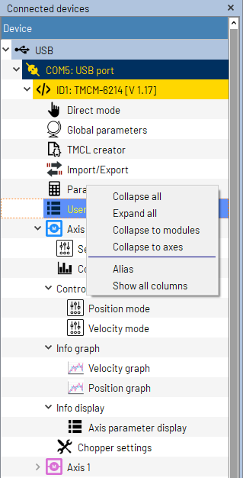
Figure 6: Tree with Connected Devices and their Tools
Mouse right click will open a popup menu. An useful item maybe Alias in case some identical modules are connected. Alias is a column with editable fields in the module rows so a unique name can be given.
If selected the TMCL history window and/or the advanced tooltip window will also be shown. These, the icon bar and device tree are freely moveable and can be arranged to an own layout.
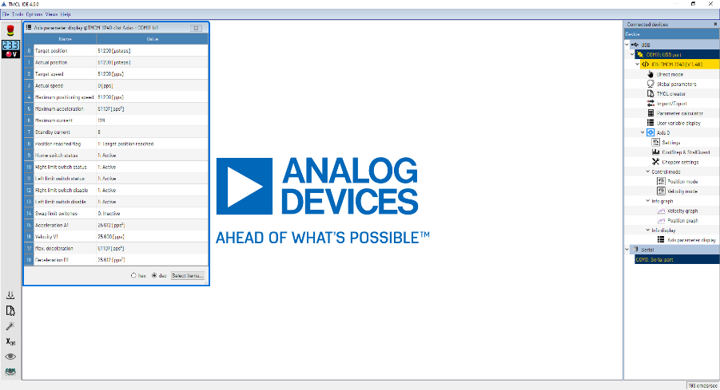
Figure 7: The TMCL-IDE Main Window with user layout

3 Connections
Depending on the host interfaces the module is equipped with there are different ways to connect the module to the PC. Many, but not all modules are equipped with a USB interface which is often the easiest way for a first connection to a PC. But also RS485, RS232 or CAN can be used to connect the module. All modules are equipped with at least one of these interfaces.

3.1 USB
For using a module with USB connection just plug in the USB cable into the module and the PC. Many TRINAMIC modules are also USB powered, but this will only work for configuring the module. USB power is not sufficient for powering motors, so it will always be necessary to connect the module also to a power supply in order to be able to run a motor using USB connection.
After plugging in the USB cable, the module will automatically appear in the module tree on the left hand side of the main window, and the tool tree that contains all tools that can be used with this module will be displayed underneath the module entry in the tree. Depending on the operating system of your PC it might be necessary to install the correct USB driver files for the module you are using. Mostly this will be done automatically by the TMCL-IDE. Sometimes it may also be necessary to install the driver manually. For this purpose, the driver files can be downloaded from the TRINAMIC website.
As all TRINAMIC modules that are equipped with a USB interface use the CDC class (communication device class) they will appear as virtual serial ports. Depending on the operating system they will either be shown as COMxx or /dev/ttyUSBxx, where xx stands for any number allocated by the operating system.
Clicking on the virtual COM port shown in the tree view will open the connection window for this port.
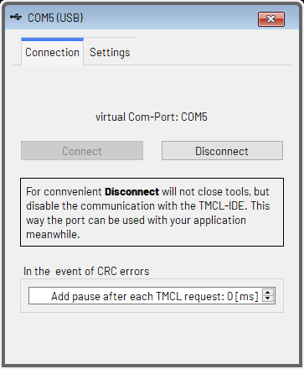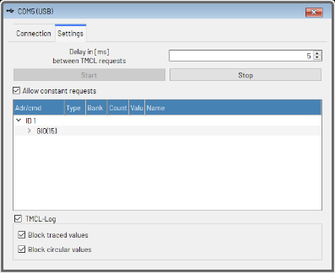
Figure 8: The USB Connection Window

3.1.1 Connection
On the Connection tab of the USB connection window general connection settings can be made:
- Using the Disconnect button it is possible to temporarily close the USB connection to the module, so that other PC software can connect to the module without having to close the TMCL-IDE itself.
- Use the Connect button to reconnect to the module after the connection had been closed using the Disconnect button. Please be sure that no other program is accessing the module via the USB interface before reconnecting.
- Pause between TMCL commands: in some rare cases it seems to be necessary to insert pauses between commands as otherwise errors might occur. If this happens, set this value higher than zero. Normally this setting can be left at zero.

3.1.2 Settings
Use the Settings tab of the USB connection window to control the regular polling of values from the module. This is needed for tools that regularly need to update values that they are displaying, like the Position Graph or the Velocity Graph for example. The following settings can be made here:
- Delay between TMCL requests: This is the polling interval. By default this is set to 5ms, but can be set lower or higher if needed.
- Use the Stop button to stop the timer. This will stop polling values from the module. Values being displayed in most tools will not be updated anymore then.
- Use the Start button to start the timer. Values displayed in the tools will then be updated again.
- The Allow constant requests checkbox controls the regular polling of some other values like the actual voltage for the supply voltage display in the TMCL-IDE while the polling timer is running.
The list in the middle section of the tab contains all TMCL parameters that are regularly polled. The check-boxes in the bottom section of the tab control the logging of the TMCL communication (which parts of the TMCL communication will be displayed in the TMCL Log window):
- The TMCL Log checkbox generally switches on or off the history display for this module.
- Block Traced Values: This function prevents values that are regularly traced by the tools from being displayed in the TMCL Log window. Switching on this option considerably reduces the amount of data being displayed in the TMCL Log window.
- Block Circular Values: This function prevents values that are polled by the tools using the timer from being displayed in the TMCL Log window. Turning on this option also considerably reduces the amount of data being displayed in the TMCL Log window.

3.2 RS485 / RS232
Many TRINAMIC modules can also be connected via RS485, RS232 or a TTL level serial interface. The TMCL-IDE can also connect to modules through these types of serial interfaces. For this purpose a serial port (RS485, RS232 or TTL level) connected to the PC (for example via USB) or built into the PC (for example as a PCI card) is necessary. Serial ports from most manufacturers can be used for this purpose. Take care that the interface has been properly installed before trying to use it. Please see also the hardware manual of your module on how to properly connect the module to the serial port. Using RS485 it is also possible to connect more than one module to one port.
All serial ports (regardless of RS485, RS232 or TTL level) are shown in the tree view on the left hand side of the main window. Depending on the operating system their names are either COMxx or /dev/ttyxx where xx stands for any number allocated by the operating system. Click on the appropriate COM port (the one your module is connected to) to display the connection window for the specific port.
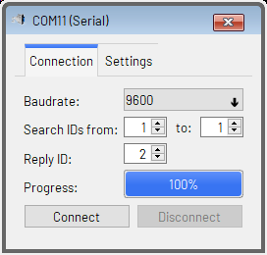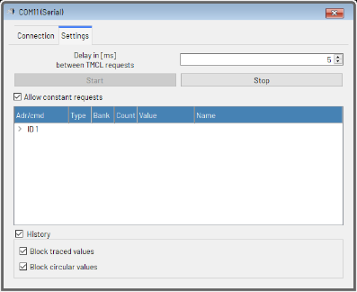
Figure 9: The Serial Port Connection Window

3.2.1 Connection
Use the Connection tab to make general settings for the connection and to connect to your module. The following options are available:
- Baudrate: Choose the baud rate of the serial port here. The factory default value on most TRINAMIC modules is 9600bps, so this value is always good for a new module. Change this if you have set up your module to use a different baud rate.
- Search IDs from/to: It is possible to connect more than one module to an RS485 bus. For this reason, the TMCL-IDE can search for more than one module on the serial port. Enter the ID of the first module connected to the bus and the ID of the last module connected to the bus here. If only one module is connected you can normally leave both values at 1, as this is also the factory default setting on TRINAMIC modules. Or if the module is set to a different ID, set both values to that ID. If you are not sure about the ID setting of a module you can also enter from 1 to 255 so that the TMCL-IDE will automatically scan through all possible serial module IDs, but this will take some time.
- Reply ID: The reply ID of the connected modules. This should normally be the same on all modules. The factory default setting is 2.
- Connect: Click the Connect button to open the connection and to start searching for modules connected to the serial port. The search progress will be shown by the progress indicator. All modules that have been found will appear on the tree view on the left hand side of the main window.
- Disconnect: Click here to close the connection.

3.2.2 Settings
Use the Settings tab of the serial port connection window to control the regular polling of values from the module. This is needed for tools that regularly need to update values that they are displaying, like the Position Graph or the Velocity Graph for example. The following settings can be made here:
- Delay between TMCL requests: This is the polling interval. By default this is set to 5ms, but can be set lower or higher if needed. The lowest possible value depends on the selected baud rate.
- Use the Stop button to stop the timer. This will stop polling values from the module. Values being displayed in most tools will not be updated anymore then.
- Use the Start button to start the timer. Values displayed in the tools will then be updated again.
- The Allow constant requests checkbox controls the regular polling of some other values like the actual voltage for the supply voltage display in the TMCL-IDE while the polling timer is running.
The list in the middle section of the tab contains all TMCL parameters that are regularly polled. The check-boxes in the bottom section of the tab control the logging of the TMCL communication (which parts of the TMCL communication will be displayed in the TMCL Log window):
- The TMCL Log checkbox generally switches on or off the history display for this port.
- Block Traced Values: This function prevents values that are regularly traced by the tools from being displayed in the TMCL Log window. Switching on this option considerably reduces the amount of data being displayed in the TMCL Log window.
- Block Circular Values: This function prevents values that are polled by the tools using the timer from being displayed in the TMCL Log window. Turning on this option also considerably reduces the amount of data being displayed in the TMCL Log window.

3.3 CAN
Modules that are equipped with a CAN interface can also be connected via the CAN bus. For this purpose, a CAN interface is needed. As CAN interfaces from different manufacturers also have different programming interfaces, not all of them are supported by the TMCL-IDE. Here are also differences between the Windows version and the Linux version of the TMCL-IDE. Table 1 contains a list of all CAN interfaces supported by the TMCL-IDE for Windows, and table 2 shows the list of CAN interfaces supported by the Linux version. Only interfaces contained in this (steadily growing) list of CAN interfaces are supported by the TMCL-IDE. Maybe other CAN interfaces from the same manufacturers will also work with the TMCL-IDE, but have not been tested by TRINAMIC.
Please see the hardware manual of your module and also the manual of your CAN interface on how to properly connect the module to the CAN interface. Using CAN it is also possible to connect more than one module to the same bus.
List of supported CAN Interfaces (Windows)
Manufacturer | Type
ESD | CAN-USB/2 CAN-USB/Micro other CAN-USB interfaces
Kvaser | Leave Light V2
Peak | PCAN-USB (IPEH-002021 or IPEF-002022) PCAN-USB Pro
IXXAT | USB-to-CAN compact USB-to-CAN V2 compact
SLCAN | Interfaces using the SLCAN protocol that use either USB VID AD50_{h} / PID 60C4_{h} (e.g. CANable firmware) or USB VID 2A3C_{h} / PID 0801_{h} (e.g. Trinamic interfaces with SLCAN firmware).
Table 1: List of supported CAN Interfaces (Windows)
List of supported CAN Interfaces (Linux)
Manufacturer | Type
SocketCAN | All interfaces that are supported by SocketCAN
Kvaser | Leave Light V2 with native driver installed
Table 2: List of supported CAN Interfaces (Linux)
All supported CAN interfaces that are attached to the PC are shown in the tree view on the left hand side of the main window. Click on the appropriate interface in the tree view to open the connection window for this interface.
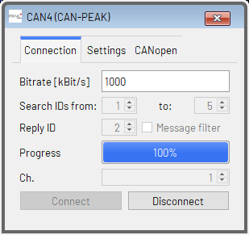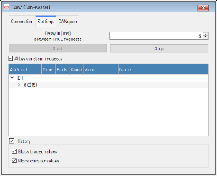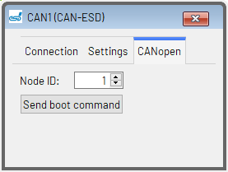
Figure 10: The CAN Bus Connection Window

3.3.1 Connection
Use the Connection tab to make general settings for the connection and to connect to your module. The following options are available:
- Bitrate: Select the desired CAN bit rate here. The factory default setting on most TRINAMIC modules is 1000kBit/s. Change this if you have set up your module to use a different bit rate.
- Search IDs from/to: It is possible to connect more than one module to a CAN bus. For this reason, the TMCL-IDE can search for more than one module on the CAN bus. Enter the ID of the first module connected to the bus and the ID of the last module connected to the bus here. If only one module is connected you can normally leave both values at 1, as this is also the factory default setting on TRINAMIC modules. Or if the module is set to a different ID, set both values to that ID. If you are not sure about the ID setting of a module you can also enter from 1 to 2047 so that the TMCL-IDE will automatically scan through all possible CAN module IDs, but this will take some time.
- Reply ID: The reply ID of the connected modules. This should normally be the same on all modules. The factory default setting is 2. When searching for modules, the reply ID will be excluded from the scan.
- Message filter: When checked, only CAN messages with the reply ID that is set here will be treated as answers from TMCL modules. All other CAN messages will be filtered out. This is useful when also other protocols are used on the same CAN bus. When only the TMCL-IDE is used then this can be switched off, so that also TMCL modules with a different reply ID can be found.
- Ch. (Channel): Some CAN interfaces are equipped with more than one CAN port. In such a case the Channel entry will be shown. The port to be used can be specified there. For CAN interfaces that are equipped with only one port (which is the case for most CAN interfaces) this setting will not be shown.
- Connect: Click the Connect button to open the connection and to start searching for modules connected to the CAN bus. The search progress will be shown by the progress indicator. All modules that have been found will appear on the tree view on the left hand side of the main window.
- Disconnect: Click here to close the connection.

3.3.2 Settings
Use the Settings tab of the CAN connection window to control the timer which is used for regularly polling values from the module. This is needed for tools that regularly need to update values that they are displaying, like the Position Graph or the Velocity Graph for example. The following settings can be made here:
- Delay between TMCL requests: This is the polling interval. By default this is set to 5ms, but can be set lower or higher if needed. The lowest possible value depends on the selected bit rate.
- Use the Stop button to stop the timer. This will stop polling values from the module. Values being displayed in most tools will not be updated any more then.
- Use the Start button to start the timer. Values displayed in the tools will then be updated again.
- The Allow constant requests checkbox controls the regular polling of some other values like the actual voltage for the supply voltage display in the TMCL-IDE while the polling timer is running.
The list in the middle section of the tab contains all TMCL parameters that are regularly polled. The check-boxes in the bottom section of the tab control the logging of the TMCL communication (which parts of the TMCL communication will be displayed in the TMCL Log window):
- The TMCL Log checkbox generally switches on or off the history display for this port.
- Block Traced Values: This function prevents values that are regularly traced by the tools from being displayed in the TMCL Log window. Switching on this option considerably reduces the amount of data being displayed in the TMCL Log window.
- Block Circular Values: This function prevents values that are polled by the tools using the timer from being displayed in the TMCL Log window. Turning on this option also considerably reduces the amount of data being displayed in the TMCL Log window.

3.3.3 Hints for Peak CAN Interfaces
After installing a Peak CAN interface for the first time it might not work together with the TMCL-IDE. This is caused by the fact that none of Peak-Systems setups install the PCANBasic.dll, which is needed by the TMCL-IDE (this DLL contains the basic Peak CAN API used by the TMCL-IDE). You need to copy the PCANBasic.dll (from the Peak CD/DVD or from the product CD section of the Peak website) manually to your Windows System directory.
- On Windows 32-bit systems:
  - – PCANBasic.dll 32 bit to Windows\System32.
- On Windows 64-bit systems:
  - – PCANBasic.dll 32 bit to Windows\SysWOW64
  - – PCANBasic.dll 64 bit to Windows\System32

4 Module specific Tools
Depending on the connected module or evaluation board, different tools appear on the tool tree. The sections in this chapter describe each of these tools.

4.1 The Main Module Tool
Click on the module name itself in the module tree to open the main module tool. This tool provides some information about the connected module itself.
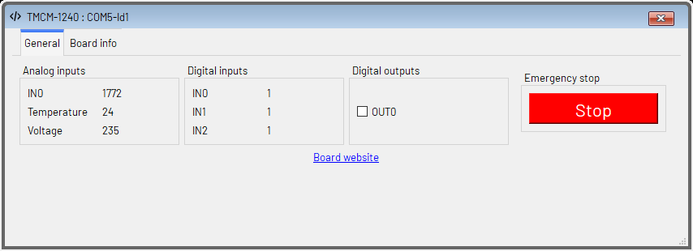
Figure 11: The Main Module Tool
On the General tab the states of all additional inputs and outputs of the module are shown. The states of additional outputs can also be changed (if the module is equipped with additional outputs). The Emergency Stop button stops all the TMCL program execution on the module and also stops all motors connected to the module.
The Board info tab provides some technical information about the module and its capabilities.

4.2 The Direct Mode
As every module that supports TMCL also supports the direct mode this tool is provided for every connected TMCL module. Direct mode means that each TMCL command that has been sent to the module directly gets executed.
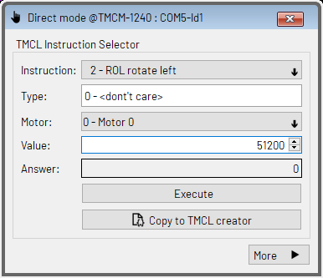
Figure 12: The Direct Mode Tool
Choose a command from the instruction selection menu. Depending on the command, you can also set the type and motor/bank parameter as well as the value parameter. Click the Execute button to send the command to the module. The reply value sent back from the module will be displayed in the Answer field.
The Copy to TMCL Creator button copies the command to the TMCL Creator.
In order to be able to see and also to modify the binary representation of a TMCL command, click the More button. The Direct Mode window will then be extended as can be seen in figure 13.
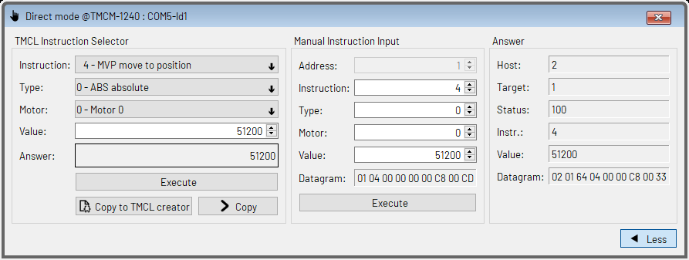
Figure 13: The Direct Mode Tool (extended)
Clicking the Copy button that now appears in the TMCL Instruction Selector area copies a command chosen here to the Manual Instruction Input area. Here it can be changed further (which is not often needed by normal users). The resulting TMCL datagram that represents this command can also be seen here. Clicking the Execute button in the Manual Instruction Input area sends this command to the module. The reply datagram will be displayed in the Answer section.

4.3 The Global Parameters Tool
Using the Global Parameters tool, the global parameters of a module can be set. These are parameters like RS232 baud rate or CAN bit rate.
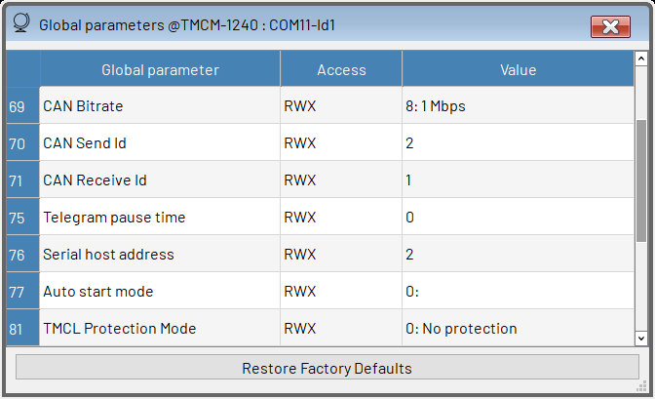
Figure 14 The Global Parameters Tool
All parameters that are supported by the connected module are shown in a list together with their current settings. To change a parameter, click on its value. The value can then be edited. The new value will be sent to the module after leaving the editor of this parameter. All these parameters are automatically stored permanently in the EEPROM of the module.
Clicking the Restore Factory Defaults button will completely reset the module. All global parameters will be restored to their factory default values, and also any TMCL program stored on the module will be erased. The Access column shows if a parameter is readable and/or writable using the following letters:
- R: parameter is readable
- W: parameter is writable
- E: parameter can be stored in the EEPROM of the module
- X: parameter can be saved using the Import/Export tool
- A: parameter is automatically stored in the EEPROM of the module
Global parameters 64. . . 127 are always automatically stored in the EEPROM of the module, even if the letter A is not shown in the Access column.

4.4 The TMCL Creator
Using the TMCL Creator it is possible to develop stand-alone TMCL programs. These programs can be downloaded to a module and then run stand-alone on that module. Not all TRINAMIC modules support stand-alone TMCL programming. So the TMCL Creator is only provided for modules that support stand-alone TMCL programming.
The central part of the TMCL Creator is its main window with its own menu bar and the TMCL program editor. The TMCL program editor mainly provides the functionality of a standard text editor with built-in syntax highlighting for TMCL. Here, TMCL programs can be entered and modified. After a program has been entered it can be assembled, downloaded to the module and run on the module.
Chapter 8 explains the syntax of the TMCL programming language. Please see also the TMCL Firmware Manual of your module to learn more about using TMCL as a programming language.
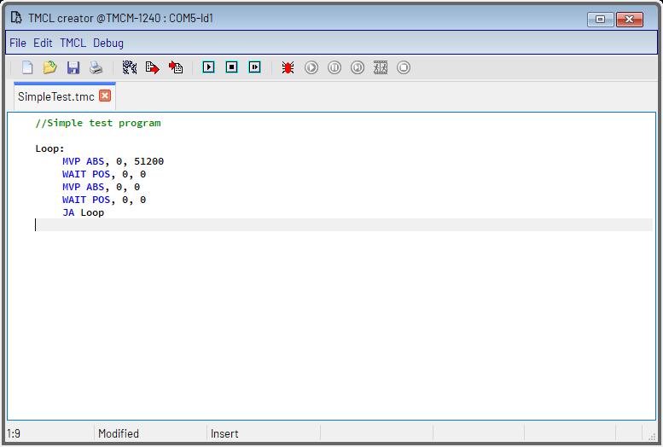
Figure 15 The TMCL Creator

4.4.1 The File Menu
The File menu of the TMCL Creator window provides the following functions:
- New: opens an empty editor tab for creating a new file.
- Open: loads a TMCL file into a new editor tab.
- Save: saves the content of the current editor tab to a file.
- Save as: saves the content of the current editor tab to a file using a new file name.
- Save all: saves all files that are currently loaded in the editor and that have been changed.
- Close: closes the currently open editor tab (same function as the close button of the editor tab).
- Print: print the content of the currently open editor tab.

4.4.2 The Edit Menu
The Edit menu provides standard text editor functions like Undo, Redo, Cut, Copy, Paste and a Find/Replace function. The Settings function opens a dialog where the text colors can be customized.
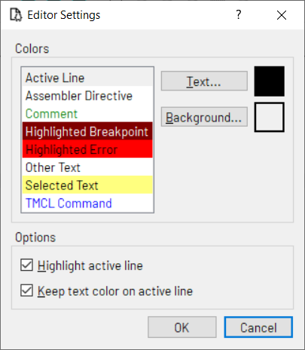
Figure 16 The Editor Settings Dialog

4.4.3 The TMCL Menu
The TMCL menu provides functions for assembling and downloading TMCL programs as well as for setting some options of the TMCL Creator. These are the following functions:

4.4.3.1 Assemble
Selecting the Assemble function in the TMCL menu assembles a file. If more than one file is open the currently selected file will be assembled. The progress of the assembly is displayed in a dialog (figure 17).
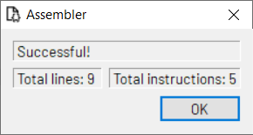
Figure 17: Progress of the Assembly
If an error occurs, the line containing the error will be highlighted and the assembly will be aborted. The error message will be displayed in the assembler progress dialog.

4.4.3.2 Download
After a TMCL program has been successfully assembled it can be downloaded into the module. To do this, select the Download function. The download progress is shown in a special dialog. Downloading can be aborted by clicking the Abort button.
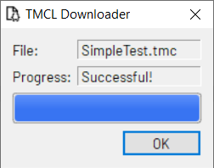
Figure 18: TMCL Program Download

4.4.3.3 Run
Select the Run function to run the TMCL program which is stored in the module. Execution then starts from the beginning of the program.

4.4.3.4 Stop
The Stop function stops a TMCL program that is running on the module. Please note that this function only stops the execution of the program. It does not stop the motors. The latter can be done by clicking the Emergency Stop button.

4.4.3.5 Continue
The Continue function continues the execution of a TMCL program that has been stopped using the Stop function from this menu.

4.4.3.6 Disassemble
The Disassemble function reads out the TMCL memory of a module and disassembles its contents. The result is written into a new editor page. This function allows checking the program which is currently stored in the TMCL program memory of a module.
The progress of downloading the program from the module and the disassembly is shown in a special dialog. It can be aborted by clicking the Abort button.
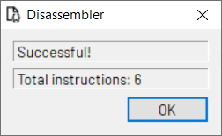
Figure 19: Program Disassembly

4.4.3.7 Options
Choosing the Options function displays the Assembler/Debugger options dialog.
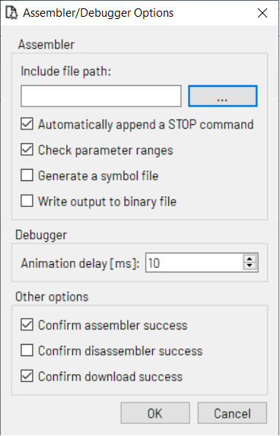
Figure 20: Assembler/Debugger Options
The following options can be set:
- Include file path: The path used to search for include files included by the #include directive.
- Automatically append a STOP command: If this option is selected the assembler automatically appends a Stop command at the end of every TMCL program (if the last command in the program is not already a STOP command).
- Check parameter ranges: All parameters used in TMCL commands will be checked against the parameter range entries in the module database of the TMCL-IDE. Violations of parameter ranges will lead to an error message. This option should normally be switched on.
- Generate a symbol file: The assembler generates a text file that contains the address of every label. This can be useful for starting the program from other addresses than 0. Please see also the sections about combining direct mode and standalone mode in the TMCL Firmware Manual of your module for more about this.
- Write output to binary file: The assembler writes its output also to a binary file. For every command eight bytes are written (the command with checksum, but without a device address).
- Animation Delay: Additional delay between two instructions when using the Animate function of the Debugger.
- Confirm assembler success: When set, the assembler dialog will stay open after successful TMCL program assembly. When not set, the assembler dialog will be closed automatically on success. Beginners should leave this option switched on (default setting), while experts might want to switch it off.
- Confirm disassembler success: When set, the disassembler dialog will stay open after successful TMCL program disassembly. When not set, the disassembler dialog will be closed automatically on success. Normally one can leave this option turned off (default setting).
- Confirm download success: When set, the download dialog will stay open after successful TMCL program download to a module. When not set, the download dialog will be closed automatically on success. Beginners should leave this option switched on (default setting), while experts might want to switch it off.

4.4.3.8 Auto Start Mode
Using this function the auto start mode of a module can be switched on or off. When auto start mode is switched on the TMCL program stored in the module will be executed automatically each time the supply power for the module is switched on.

4.4.4 The Debugger
To start the debugger either selecting Debugger active in the Debug menu or click the Debugger icon on the tool bar. The debugger then first checks if the program has been modified and in this case the program will automatically be assembled and downloaded again to be sure that the program in the editor is the same as the program stored on the module.
After the debugger has been successfully started, the debugger functions will be enabled and most other functions of the TMCL Creator will be disabled (in debug mode it is not possible to change the program in the editor). Other tools of the TMCL-IDE can still be used with care. You can exit the debugger by clicking Debugger active in the Debug menu or the Debugger icon on the tool bar once again. Then, all debugger functions will be disabled and all other functions of the TMCL-IDE will be enabled again.
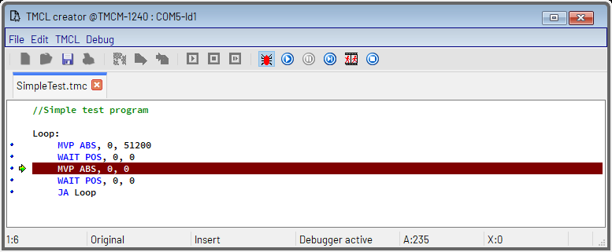
Figure 21: The TMCL Creator in Debug Mode

4.4.5 Breakpoints
Breakpoints can be set or removed by clicking the appropriate line on the left breakpoint bar of the editor. A blue bullet is displayed in every line where a breakpoint can be set. When a breakpoint is set a red bullet with a green tick will be displayed in that line.
After a program has been started either by the Run or by the Animate function of the debugger it will be stopped when a breakpoint is reached. It can be continued by clicking Run, Animate or Step again. It can also be reset by clicking Stop & Reset so that it can be restarted from the beginning again.

4.4.6 The Run/Continue Function
Choose the Run/Continue function from the Debug menu (or click the Run icon or press F9) to start the program or continue its execution. The program will be stopped either when its end is reached or when a breakpoint is reached or when the Pause function in the Debug menu or the Pause icon is selected. In the latter two cases the actual position in the program will be shown in the editor by a green arrow on the left side and the program execution can be continued by using the Run/Continue function, the Step function or the Animate function. The contents of the accumulator and the X register are also shown on the status bar while the program is paused.
If you wish to restart the program from the very beginning, select the Stop/Reset function before clicking Run/Continue.

4.4.7 The Pause Function
When a program is running (started by the Run/Continue or by the Animate function), the program execution can be interrupted at any time by selecting the Pause function from the Debug menu or by clicking the Pause icon on the tool bar or by pressing F2. Program execution can be continued by clicking Run/Continue, Animate or Step again. While a program is paused the actual position in the program is shown by a green arrow in the editor. The contents of the accumulator and the X register are shown on the status bar of the TMCL Creator window.

4.4.8 The Step Function
Use this function for a step-by-step execution of the TMCL program. Every time the Step function is selected (by selecting Step in the Debug menu, clicking the Step icon on the tool bar or pressing F7) the next command in the TMCL program will be executed. The actual position is shown by a green arrow in the editor. The contents of the accumulator and the X register are also shown on the status bar.

4.4.9 The Animate Function
This function automatically executes the TMCL program step-by-step, so that the flow of the program can be seen. The actual position in the program is shown and updated after every command, and the contents of the accumulator and the X register are also shown on the status bar and updated after every command.
The program will be paused when running into a breakpoint or when the Pause function is selected. Pro-gram execution can be continued either by the Run/Continue function, the Animate function or the Step function.

4.4.10 The Stop & Reset Function
Selecting Stop & Reset from the Debug menu (or clicking the Stop & Reset button or pressing Ctrl+F2) stops the program execution immediately and resets the program. This means that starting the program again using Run/Continue, Animate or Step will start the program from the beginning.
This function can also be used when the program execution is paused (by a breakpoint or by the Pause function) to reset it and to ensure that the program can be started again from the beginning.

4.5 The Import/Export Tool
The Import/Export tool is a utility for reading out all important settings from a module and generating TMCL source code from it. The generated code can then for example be taken over into the TMCL Creator.
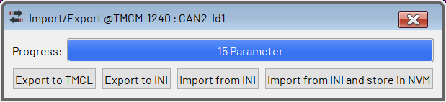
Figure 22: The Settings Export/Import Tool
The Import/Export Tool provides the following functions:
- Export to TMCL: This is the main function of this tool. It reads out all axis parameters and generates a TMCL program file that contains SAP commands for all these parameters. This file can then be used for example with the TMCL Creator.
- Export to INI: This function reads out all axis parameter settings and stores them in an INI file. The INI file can be used to download the parameters later, using this tool. INI files can only be used with this tool.
- Import from INI: Use this function to download all axis parameters that have previously been saved using the Export to INI function.
- Import from INI and store to NVM: This does the same as Import from INI, but additionally stores the axis parameters in the EEPROM (NVM, non-volatile memory) of the module. Note that storing axis parameters to the NVM is not possible on all modules and not with all axis parameters.

4.6 The Parameter Calculator
The Parameter Calculator is a utility for converting between different units of motion parameters like the velocity and the acceleration. There are two different versions of the Parameter Calculator: one for step-per motor modules that are based on the TMC429 motion controller (older modules like the TMCM-140, TMCM-343, TMCM-351, TMCM-1110, TMCM-1140, TMCM-1141, TMCM-1160, TMCM-1161, TMCM-1180, TMCM-1181, TMCM-3110 and TMCM-6110) where internal units are used for velocity and acceleration parameters and one for all other stepper motor modules where velocity and acceleration values are given as pps (pulses per second) units.
The TMCL-IDE will always automatically show the version of the Parameter Calculator that fits for the connected module.

4.6.1 TMC429 based Stepper Motor Modules
The Parameter Calculator for TMC429 based stepper motor modules helps to convert between physical units for velocity and acceleration and the internal units used by those modules that are based on the TMC429 motion controller.
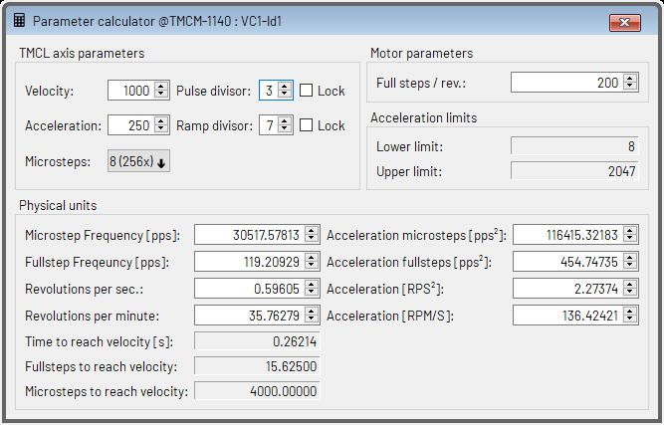
Figure 23: The Parameter Calculator for TMC429 based Stepper Motor Modules
It is capable of converting from internal units to physical units as well as from physical units to internal units. Just change the value that you would like to convert and see how the other values get changed then. When changing a physical value the Parameter Calculator normally tries to find the best combination of pulse divisor and/or ramp divisor and velocity and/or acceleration to achieve this value. This results in the fact that pulse divisor and/or ramp divisor also get changed. If you do not wish the pulse divisor and/or the ramp divisor to get changed automatically check the Lock checkbox beside the pulse divisor and/or the ramp divisor.
With some parameter combinations there are restrictions concerning the acceleration value. Such restrictions are also shown by the Parameter Calculator.
Please see the TMCL Firmware Manual of your module to learn more about the relations between the internal units of the module and the physical units for velocity and acceleration.

4.6.2 Stepper Motor Modules that use pps Units
The Parameter Calculator for stepper motor modules that use pps units just converts between pulses per second and units like rounds per minute or rounds per second.
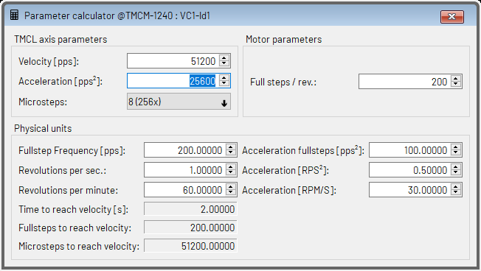
Figure 24: The Parameter Calculator for all other Stepper Motor Modules
The Parameter Calculator can convert from pps units to the other units as well as from other units back to pps units. Just change the value that you would like to convert and see how all other parameters that depend on this value are automatically re-calculated then.
Please see also the TMCL Firmware Manual of your module to learn more about the relations between the different physical units.

4.7 The User Variable Display
The User Variable Display is a tool for displaying the contents of selected TMCL user variables with automatic periodic update. This allows permanent monitoring of TMCL user variables (which is also possible while a TMCL program is running on the module). It can be used for example to help debugging a TMCL program. This tool is provided for all modules that support stand-alone TMCL programming.
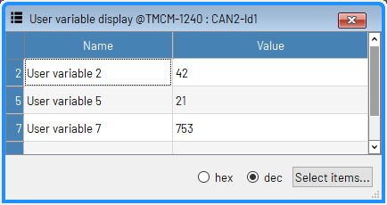
Figure 25: The User Variable Display
The contents of the displayed user variables can be presented in decimal or in hexadecimal form. This can be selected using the buttons at the bottom of the window. The displayed user variable contents are updated periodically, as fast as set up in the timer settings of the module connection. Clicking the Select button will show a dialog for selecting which variables are to be displayed.

4.8 The Settings Tool (Stepper Motor)
The Settings tool allows changing basic axis-specific settings. It is provided once for each axis of the connected module. Depending on the module type this tool looks different, as different modules might offer different axis settings.
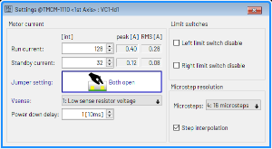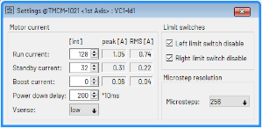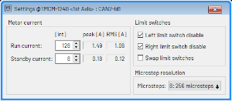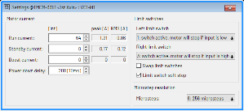
Figure 26: Different Appearances of the Settings Tool
The main settings that can be made here are the motor run current and standby current, the functionality of the limit switches and the micro step resolution. Most changes made here will become effective immediately. Each setting corresponds to one axis parameter in TMCL. The corresponding parameter numbers are shown when hovering over a setting with the mouse pointer. Please see the TMCL Firmware Manual of your module to learn more about each parameter.

4.9 The Closed Loop Tool
The closed-loop tool is provided for each axis of a closed-loop stepper motor module. With the help of the closed-loop tool it is possible to activate and to tune the closed-loop feature of such modules.
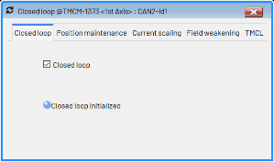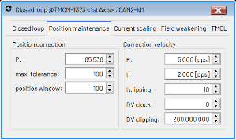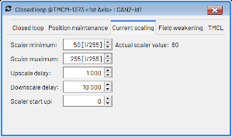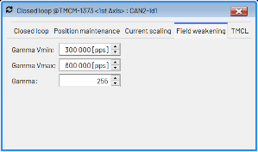
Figure 27: The Different Tabs of the Closed Loop Tool
The checkbox on the first tab switches the closed loop function of the module on and off. Hovering with the pointer of one of the closed-loop parameters shows the axis parameter number. Please see the TMCL Firmware Manual to learn more about the close loop parameters.
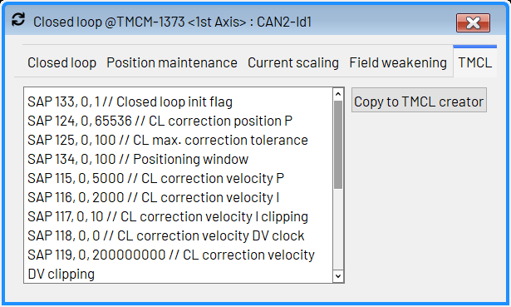
Figure 28: The TMCL Tab of the Closed Loop Tool
On the TMCL tab all settings are shown as TMCL commands. Click the Copy to TMCL Creator button to copy all these commands to the editor of the TMCL Creator.

4.10 The Chopper Settings
The Chopper Settings tool is provided for all modules that also support the StealthChop mode. All settings that are necessary to use the StealthChop mode can be made in an interactive way using this tool. After having made all necessary settings, the TMCL commands that are necessary to set up StealthChop can directly be copied to the TMCL Creator.

4.10.1 The Thresholds Tab
On the Thresholds tab the threshold speeds for switching between different chopper schemes can be set.
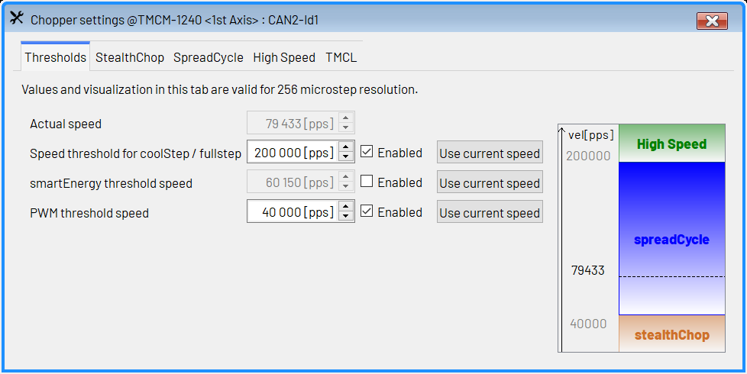
Figure 29: Chopper Settings — Thresholds
To use this tool, first run the motor at the desired velocity using the Velocity Mode tool. Now, set up the threshold speeds for switching between the different chopper modes. Click the Use current speed button to use the actual speed as a threshold speed. The following settings can be made:
- Actual speed: Shows the actual speed the motor is running at.
- Speed threshold for CoolStep / fullstep: it is possible to switch to fullstep mode and/or to a different chopper scheme when the speed is above the activation velocity for this mode. Check the Enabled check box to activate this feature. The features that are to be activated can be chosen on the High Speed tab.
- smartEnergy threshold speed: above this speed, CoolStep can be activated. Use the CoolStep tool to further parametrize CoolStep. Check the Enabled checkbox to activate this threshold speed.
- PWM threshold speed: if the speed drops below this speed the StealthChop scheme can be activated to make the motor run quietly. Check the Enabled checkbox to activate this feature.
Try running the motor at different speeds below and above each threshold to be sure that the motor runs stable with these settings.

4.10.2 The StealthChop Tab
Use the settings on the StealthChop tab to further parametrize the StealthChop chopper scheme. This is needed to adapt StealthChop to different motors. In many cases the factory default values do not need to be changed much.
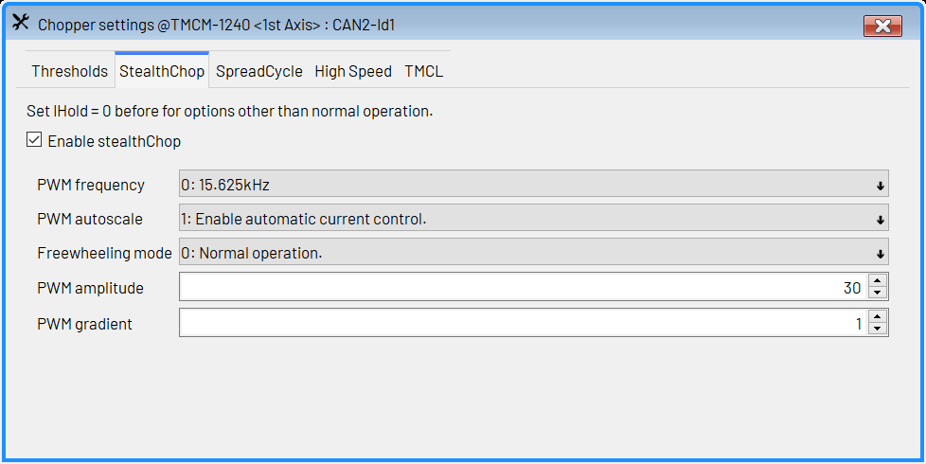
Figure 30: Chopper Settings — StealthChop
The following settings can be made here:
- PWM frequency: the frequency of the chopper PWM.
- PWM autoscale: enable or disable automatic PWM scaling. Should normally be enabled.
- Freewheeling mode: in StealthChop mode, a freewheeling mode can be chosen which becomes active when the motor is stopped and the standby current (axis parameter #7) is set to 0.
- PWM amplitude: Maximum PWM amplitude when switching to StealthChop mode. Do not set too low. Values above 64 recommended with most modules.
- PWM gradient: Velocity dependent gradient for the PWM amplitude.

4.10.3 The SpreadCycle Tab
On the SpreadCycle tab, all settings that are specific to the default chopper scheme can be made.
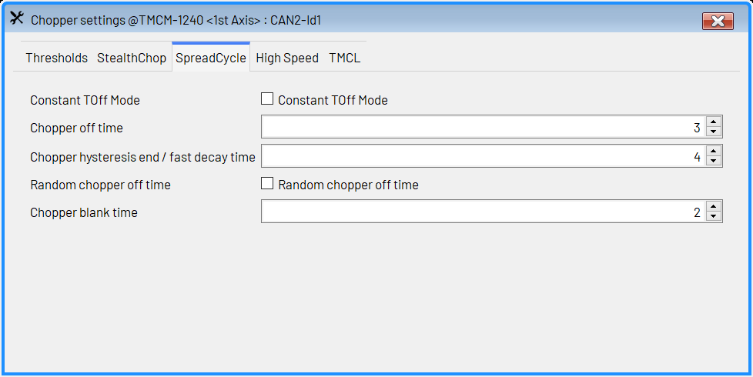
Figure 31: Chopper Settings — SpreadCycle
- Constant TOff Mode: This will switch off the SpreadCycle chopper scheme and will use a classic constant off time chopper scheme instead.
- Chopper off time: Controls the minimum chopper frequency.
- Chopper hysteresis end / fast decay time: For SpreadCycle chopper mode this parameter sets the hysteresis end setting. For classic constant off time chopper mode this parameter sets the fast decay time.
- Random chopper off time: Switches between fixed chopper off time and random chopper off time.
- Chopper blank time: Selects the comparator blank time. Normally leave at default value.
For most cases, leave these values at their default settings. Please see the TMCL Firmware Manual of your module for more information about these settings.

4.10.4 The High Speed Tab
On the High Speed tab it is possible to choose options that become active when the actual speed becomes greater than the high speed threshold value.
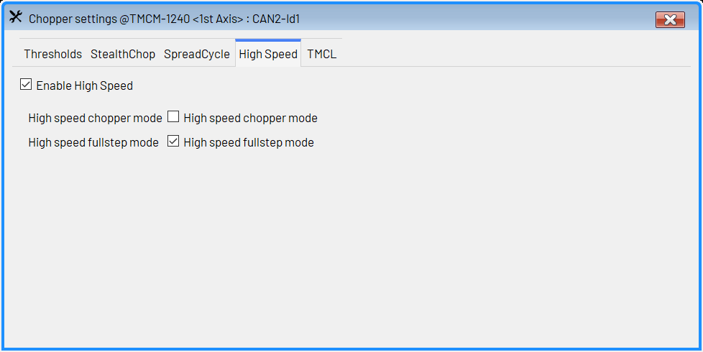
Figure 32: Chopper Settings — High Speed
The following options can be chosen here:
- High speed chopper mode: Switch to a different chopper mode when this option is checked and the speed is above the high speed threshold value.
- High speed fullstep mode: Switch to fullstep mode when this option is checked and the speed is above the high speed threshold value.

4.10.5 The TMCL Tab
On the TMCL tab, all settings made using the Chopper Settings tool are shown as TMCL commands.
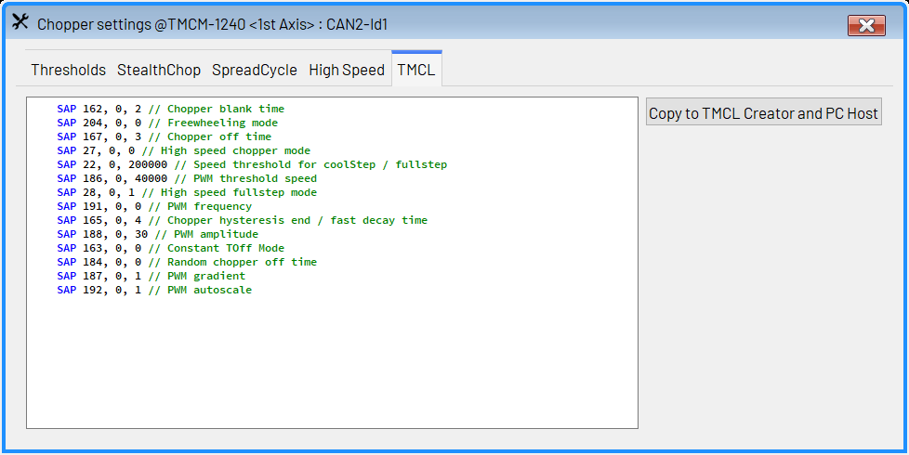
Figure 33: Chopper Settings — TMCL
Click the Copy to TMCL Creator button to copy all the commands to the TMCL Creator or to the TMCL/PC Host. You can then easily use these settings in your TMCL program.

4.11 The Velocity Graph
The Velocity Graph is a tool for graphically displaying axis parameters, user variables and the states of input/output ports of the module. It is pre-configured for displaying the actual velocity and the target velocity, but it can be used for graphically monitoring also anything else. This can help for example when tuning ramp parameters or also when debugging a TMCL program that is running on the module. The data will be updated as fast as set up in the timer setting of the module connection.
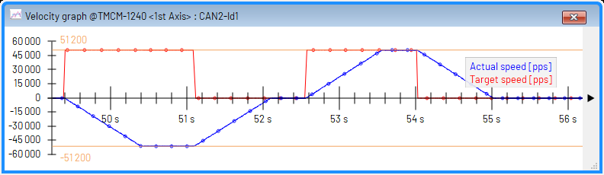
Figure 34: The Velocity Graph
Click the right mouse button over the graph window to display the context menu of the graph display window. The context menu offers some options for changing the appearance of the graph and for selecting the items that are to be displayed:
- Bold points: Selects if each data point of the graph shall be displayed as a bold point or just as a small point.
- Points only: Selects if the data points are to be linked by lines or just the data points are to be shown, not linked by lines.
- Show min/max marker: Selects if marker lines for the actual maximum and minimum values are to be shown.
- Normalize data: Selects if the data is to be normalized to the maximum and minimum scale values or if just the visible part of the graph is to be shown.
- Select items: Displays a dialog that allows selecting which parameters are to be displayed in the graph (please see section 4.11.1).
- Change order: Shows a dialog that allows changing the order of the parameters displayed in the graph.

4.11.1 Selecting Parameters to be displayed
The parameter selection dialog allows selecting the parameters that are to be displayed in the graph window.
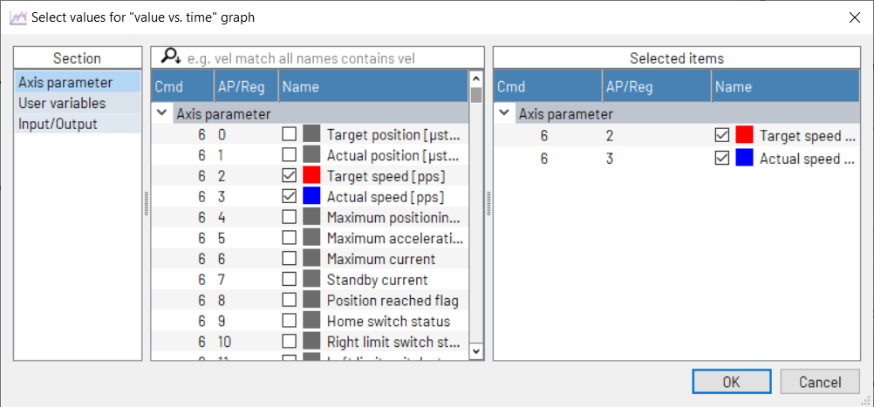
Figure 35: The Parameter Selection Dialog
It is grouped into three sections:
- Section: Here you can select between axis parameters, user variables and input/output ports.
- Parameter list: Pick parameters that are to be displayed from this list or deselect parameters that are no longer to be displayed here.
- Selected items: This shows which items are selected from each section. Right-click on a colored box to change the display color of an item.

4.11.2 Other Options
Click the arrow button on the right hand side of the graph window to select scaling options.
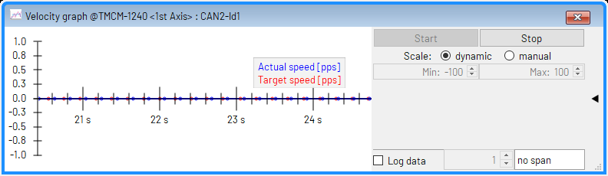
Figure 36: Graph Scaling Options
Here the following options can be selected:
- Stop: The Stop button stops the graph so that it can be viewed.
- Start: Clicking the Start button re-starts refreshing of the graph.
- Clear: This button clears the data buffer of the graph.
- Default: Sets all graph scaling parameters back to default values.
- Max. and Min.: Maximum and minimum values of the y scale of the graph.
- Save current buffer: saves the currently displayed data to a CSV file.
- Log: Logging can be enabled to continuously save the graph data to a CSV file. Either every data point can be logged (when no span is selected), or the data can be logged in configurable spans of seconds or minutes.
Click the arrow button on the right hand side of the window again to hide these options.

4.12 The Position Graph
The Position Graph is a tool for graphically displaying axis parameters. It works exactly the same way as the Velocity Graph (please see there), with the only exception that it is pre-configured for showing the actual position and the target position.
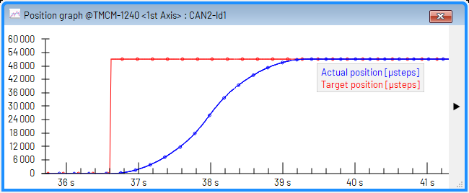
Figure 37: The Position Graph

4.13 The Torque Graph
The Torque Graph is a tool for graphically displaying axis parameters. It works exactly the same way as the Velocity Graph (please see there), with the only exception that it is pre-configured for showing the actual torque and the target torque. It is provided for BLDC motor modules only.
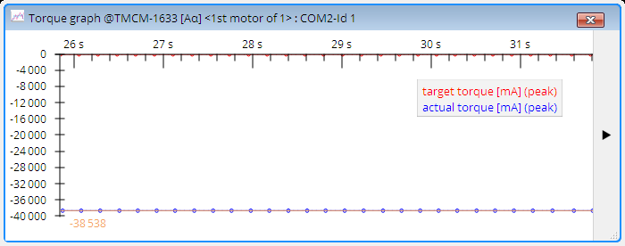
Figure 38: The Torque Graph

4.14 The Velocity Mode
The velocity mode is a tool that allows running a motor at a selectable velocity. Depending on the capabilities of the module the velocity mode window looks different. Some modules are using different velocity units or have different options for the velocity mode. The different versions of the velocity mode all have the same basic functions.
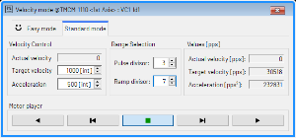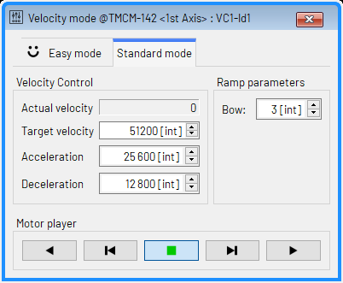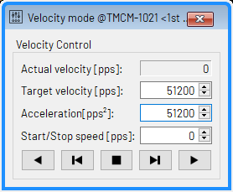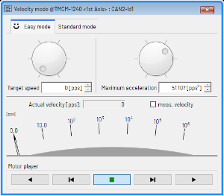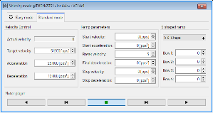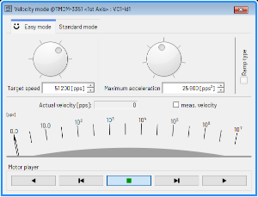
Figure 39: Different Appearances of the Velocity Mode Tool
The different versions of the velocity mode tool always provide the same buttons for moving the motor:
- The motor continuous running in negative direction until clicking the stop button or a different button for running the motor.
- The motor runs in negative direction as long as the button is being pressed. When releasing the button the motor will be stopped.
- Stop: clicking this button will stop the motor.
- The motor runs in positive direction as long as the button is being pressed. When releasing the button the motor will be stopped.
- The motor continuous running in positive direction until clicking the stop button or a different button for running the motor.
Depending of the capabilities of the module the units are either internal units of the module ([int]) or microsteps per second (pulses per second, [pps]) or revolutions per minute ([prm]). Some versions of the velocity mode tool also provide an Easy Mode, where the most important parameters can be set using dials or sliders.

4.15 The Position Mode
The position mode is a tool that allows driving a motor to selectable positions. Depending on the capabilities of the module the position mode window looks different. Some modules are using different velocity units or have different options for the position mode. The different versions of the position mode all have the same basic functions. The positions are always given as microsteps.
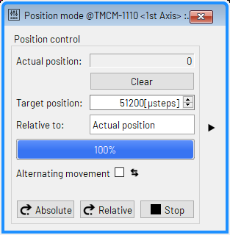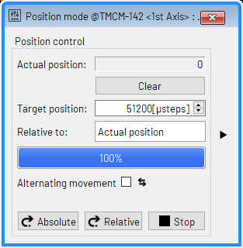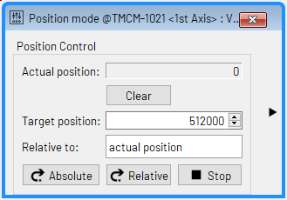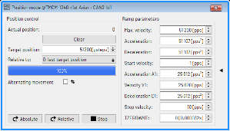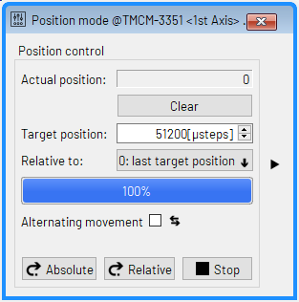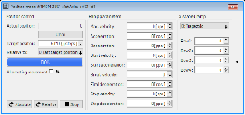
Figure 40: Different Appearances of the Position Mode Tool
The basic functions are the same in all versions of the position mode tool:
- Actual Position: Shows the actual position given in microsteps.
- Target Position: Enter the target position here, given in microsteps.
- Absolute: Click this button to move to the given target position, as absolute position. This generates an MVP ABS command.
- Relative: Click here to use the given target position as a relative offset to the actual position. This generates an MVP REL command.
- Relative to: Depending on the module and its firmware version it is possible to select the base used for a relative move. This can either be the actual position, the last target position or (on some closed loop modules) the encoder position.
- Click the arrow on the right edge of the window to show or hide the ramp parameters.

4.16 The Torque Mode (Stepper Motor)
With some closed-loop stepper motor modules it is also possible to drive the stepper motor using torque mode. This is only possible when closed-loop mode is active.
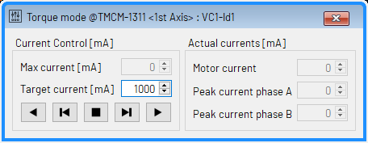
Figure 41: The Torque Mode for Stepper Motors
Please see the TMCL Firmware Manual of your module for more about this.

4.17 The Torque Mode (BLDC Motor)
With BLDC motor modules it is also possible to drive the motor using torque mode. This can be controlled using the Torque Mode tool.
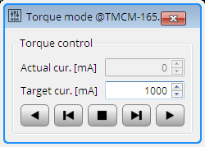
Figure 42: The Torque Mode for BLDC Motors
The desired motor current can be entered, and the actual motor current is also shown. The following functions are provided:
- The motor continuous running in negative direction until clicking the stop button or a different button for running the motor.
- The motor runs in negative direction as long as the button is being pressed. When releasing the button the motor will be stopped.
- Stop: clicking this button will stop the motor.
- The motor runs in positive direction as long as the button is being pressed. When releasing the button the motor will be stopped.
- The motor continuous running in positive direction until clicking the stop button or a different button for running the motor.

4.18 The Axis Parameter Display
The Axis Parameter Display is a tool for displaying the values of selected axis parameters with automatic periodic update. This allows permanent monitoring of axis parameters (which is also possible while a TMCL program is running on the module). It can be used for example to help debugging a TMCL program. This tool is provided for all modules that support axis parameters (which most of the TRINAMIC modules do).
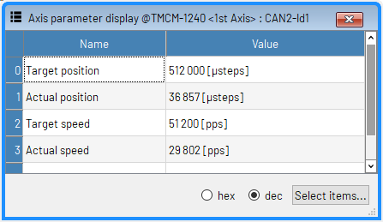
Figure 43: The Axis Parameter Display
The contents of the displayed axis parameters can be presented in decimal or in hexadecimal form. This can be selected using the buttons at the bottom of the window. The displayed axis parameter values are updated periodically, as fast as set up in the timer settings of the module connection. Clicking the Select button will show a dialog for selecting which axis parameters are to be displayed.

4.19 The StallGuard Adjuster
The StallGuard adjusting tool is provided for modules that are equipped with the StallGuard (not the Stall-Guard2) feature. These are older modules like the TMCM-140, the TMCM-343 or the TMCM-351. This tool helps to find the necessary motor parameters when StallGuard is to be used. Figure 44 shows the StallGuard Adjuster tool.
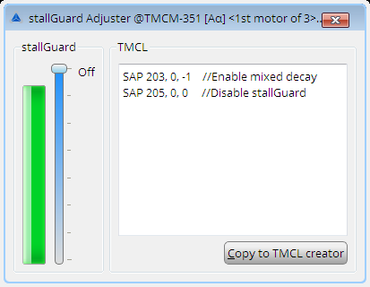
Figure 44: The StallGuard Adjuster
Use this tool as follows:
- Use the Velocity Mode tool to run the motor at a specific velocity.
- The green bar in the StallGuard Adjuster displays the actual load value. Use the slider to set the StallGuard threshold value. The motor will be stopped automatically if the load value reaches this value.
- The necessary settings are also displayed as TMCL commands in the TMCL area of the StallGuard Adjuster window. Click the Copy to TMCL Creator button to copy the commands to the TMCL Creator.

4.20 The StallGuard Profiler
The StallGuard profiler tool is provided for modules that are equipped with the StallGuard (not the Stall-Guard2) feature. These are older modules like the TMCM-140, the TMCM-343 or the TMCM-351. This tool helps to find the best settings for using stall detection. It scans through given velocities and shows which velocities are the best ones to be used with StallGuard.
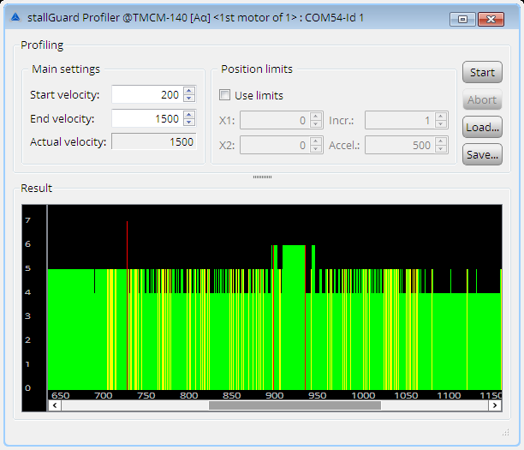
Figure 45: The StallGuard Profiler
Here is how to use the StallGuard profiler:
- First, enter the start velocity and the end velocity. The start velocity is used at the beginning of the profile recording. The recording ends when the end velocity has been reached. Start velocity and end velocity must not be equal.
- After these parameters have been entered, click the Start button to start the StallGuard profile recording. Depending on the range between start and end velocity this can take several minutes, as the load value for every velocity value will be measured ten times.
- The actual velocity value shows the velocity that is currently being tested and so tells about the progress of the profile recording.
- The recording of the profile can also be aborted by clicking the Abort button.
- It is also possible to limit the motion between two positions. To use this feature, check the Use Limits checkbox and enter position limits. This is useful for example when recording the StallGuard profile of a linear drive.
- A StallGuard profile that has been recorded can be saved using the Save button and loaded for viewing it again using the Load button.

4.20.1 The Result of the StallGuard Profiler
The result is shown graphically in the StallGuard profiler window. After the profile recording has finished you can scroll through the profile graph using the scroll bar below it. The scale on the vertical axis shows the load value: A higher value means a higher load. The scale on the horizontal axis is the velocity scale. The color of each line shows the standard deviation of the ten load values that have been measured for the velocity at that point. This is an indicator for the vibration of the motor at the given velocity.
Three colors are used:

- Green: The standard deviation is very low or zero. This means that there is effectively no vibration at this velocity.
- Yellow: This color means that there might be some low vibration at this velocity.
- Red: The red color means that there is high vibration at that velocity.

4.20.2 Interpreting the Result
In order to make effective use of the StallGuard feature one should choose a velocity where the load value is as low as possible and where the color is green. The very best velocity values are those where the load value is zero (areas that do not show any green, yellow or red line).
Velocities shown using yellow color can also be used, but with care as they might cause problems (maybe the motor will stop even when not being stalled).
Velocities shown using red color should not be chosen. Because of vibration the load value is often un-predictable and so not usable to achieve good results when using stall detection.
It is unlikely that exactly the same result is produced when recording a profile with the same parameters again. Always two or more profiles should be recorded and compared against each other in order to get a stable result.

4.21 The CoolStep & StallGuard2 Tool
The CoolStep & StallGuard2 tool is provided for modules that are equipped with the CoolStep and the StallGuard2 feature. These are most newer TRINAMIC stepper motor control modules. It helps to find the necessary motor parameter adjustments when StallGuard2 and CoolStep are to be used.
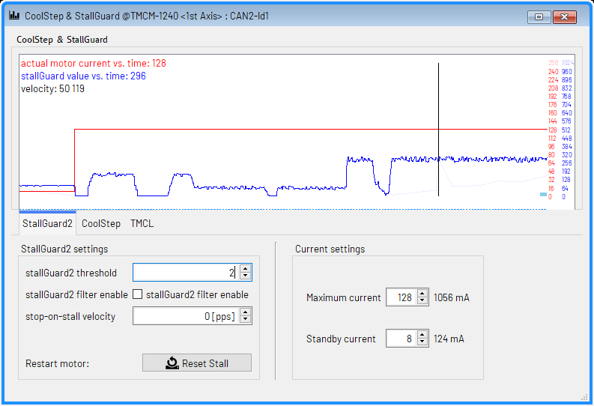
Figure 46: The CoolStep & StallGuard2 Tool
This tool consists of a graph that shows the load value (blue line) and the motor current value (red line) and three tabs which concern different aspects of these features:
- StallGuard2
- CoolStep
- TMCL
The CoolStep & StallGuard2 tool provides an interactive way for adjusting the necessary settings. All settings that can be made on the StallGuard2 tab and on the CoolStep tab are immediately represented as TMCL commands on the TMCL code tab.

4.21.1 The StallGuard2 Tab
The StallGuard2 tab contains the following parameters:
- Filter enable (SAP 173): this parameter enables the StallGuard2 filter for more precision of the measurement. If enabled, the measurement frequency will be reduced to one measurement per four fullsteps. In most cases it is expedient to enable the filter before using CoolStep.
- stallGuard threshold (SAP 174): this value controls the threshold level for stall detection and sets the optimum measurement range for the load value readout. A lower value will result in a higher sensitivity. Higher values will cause StallGuard2 to be less sensitive.
- stall velocity threshold (SAP 181), also called stop-on-stall velocity threshold: the motor will be stopped automatically if a stall has been detected and the actual velocity is higher than this value. Setting this value to zero turns off this feature.
- Reset Stall: with some modules it is necessary to click this button to be able to re-start the motor after it has been stopped by the stop-on-stall feature.
- Run Current (SAP 6): the run current of the motor can also be set here.
- Standby Current (SAP 7): the standby current of the motor can also be set using this tool.
Please see the TMCL Firmware Manual of your module for further details about these parameters.
To set up the StallGuard2 parameters, first run the motor at the desired velocity using the Velocity Mode tool. Now, set the stallGuard threshold value in such a way that the blue line reaches zero when the motor is being obstructed (stalled). The blue line should be as far away from zero as possible when the motor is running normally. Always try different velocities. The StallGuard2 feature does not work the same with all velocities.

4.21.2 The CoolStep Tab
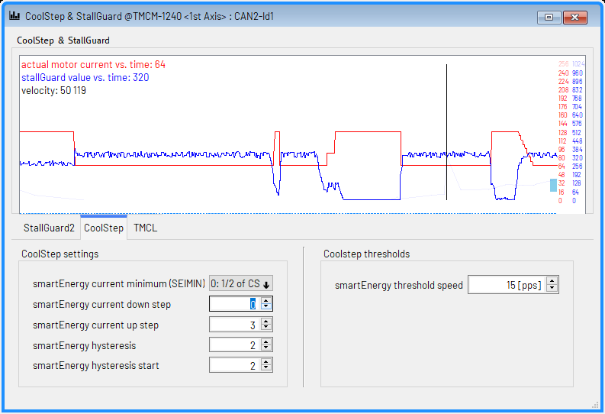
Figure 47: The CoolStep Tab
The CoolStep tab represents all settings that are necessary for using the CoolStep feature. These are mainly the following parameters:
- Current minimum (SAP 168): this can be 1/2 or 1/4 of the run current.
- Current down step (SAP 169): determines how fast the current is to be lowered when the load value is above upper end of the CoolStep hysteresis.
- Current up step (SAP 171): determines how fast the current is to be raised when the load value is below the lower end of the CoolStep hysteresis.
- Hysteresis width (SAP 170): determines the width and hence the upper end of the CoolStep hysteresis.
- Hysteresis start (SAP 172): determines the lower end of the CoolStep hysteresis.
- Threshold speed (SAP 182): CoolStep will become active when the actual velocity of the motor is above this value. Setting this value to zero makes CoolStep always become active.
- Slow run current (SAP 183): The motor will run using this current when the velocity is below the threshold speed, but greater than zero.
Please see the TMCL Firmware Manual of your module for further details about these parameters.
To set up the CoolStep parameters, first run the motor at the desired velocity using the Velocity Mode tool. Leave the threshold speed at zero first. Now, choose a CoolStep hysteresis using the hysteresis start and width values. The hysteresis is also being shown as a blue bar on the right hand side of the graph. Then, also set up the current down step and current up step parameters as well as the current minimum parameter. The red line in the graph shows how the current is being lowered or raised. If desired you can now also set the threshold speed and slow run current.

4.21.3 The TMCL Tab
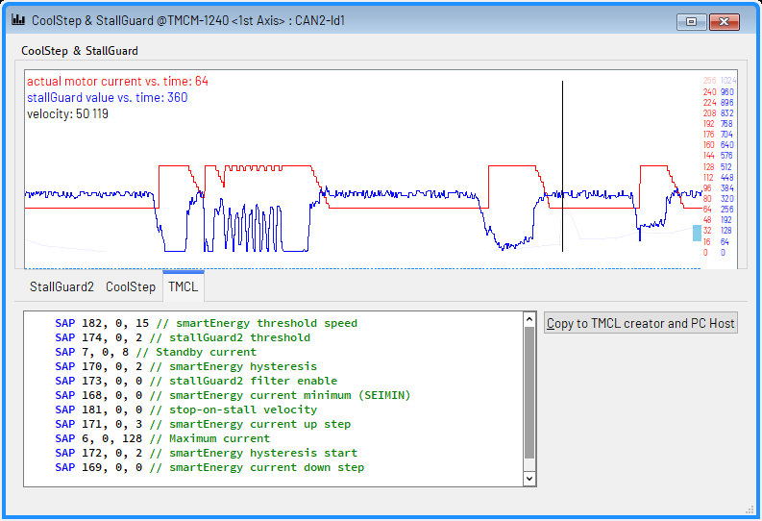
Figure 48: The TMCL Tab
The TMCL tab shows all adjustments which have been made on the other tabs of the CoolStep & Stall-Guard2 tool as TMCL commands. Clicking the Copy to TMCL Creator button will copy all these commands to the TMCL Creator tool.

4.22 The Settings Tool (BLDC Motor)
The BLDC Settings tool provides functions for configuring a BLDC motor control module for use with a specific motor. It is provided once for each axis of the connected module.
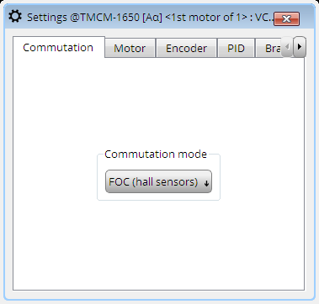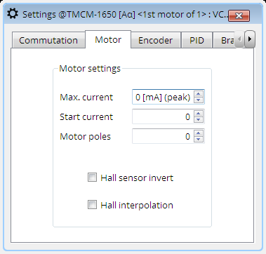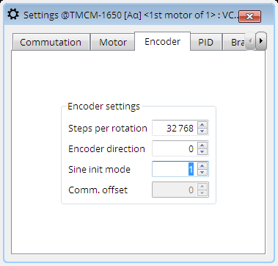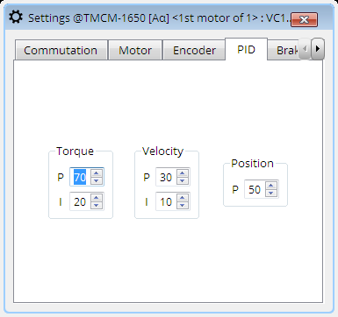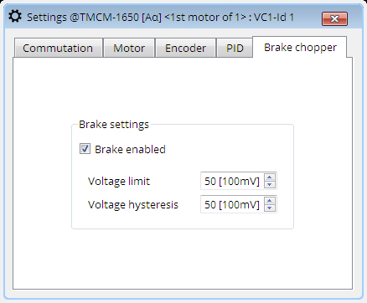
Figure 49: The BLDC Motor Settings Tool
Depending on the module itself, some settings might not be shown as not all modules support all these settings. The settings are grouped into the following tabs:
- Commutation: All commutation modes supported by the module are shown here. Pick the desired commutation mode from the list.
- Motor: All settings that are specific to the motor itself are shown here. These are mainly the maximum current, start current, number of poles and (if supported) if the hall signals have to be inverted or hall interpolation is to be used.
- Encoder: If supported, all settings specific to the encoder can be set here. These are the encoder steps per rotation (encoder resolution), encoder direction and the encoder initialization mode.
- PID: These are the parameters of the PID regulators.
- Brake chopper: If supported by the module, settings for an optional brake resistor can be made here.
After modifying a numerical value here, its background color will be changed to orange. This means that the modified value has not yet been sent to the module. Press the ENTER key on the keyboard to send the new value to the module. Its background color will then become white again. Each setting corresponds to one axis parameter in TMCL. The corresponding parameter numbers are shown when hovering over a setting with the mouse pointer. Please see the TMCL Firmware Manual of your module to learn more about each parameter.

4.23 The Flags Tool (BLDC Motor)
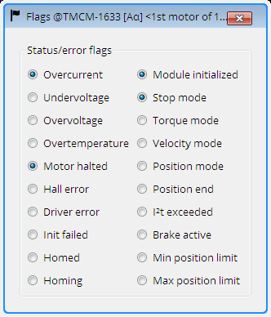
Figure 50: The BLDC Motor Flags Tool
The flags tool shows the states of all status flags and the states of all error flags that are provided by the connected module. Please see the TMCL Firmware Manual of your module to learn more about the status flags and the error flags provided by your module.

4.24 The Parameter Display
The Parameter Display is a tool for displaying the contents of selected TMCL axis parameters and user variables with automatic periodic update. This allows permanent monitoring of TMCL axis parameters and user variables (which is also possible while a TMCL program is running on the module). It can be used for example to help debugging a TMCL program. This tool is provided for BLDC motor modules.
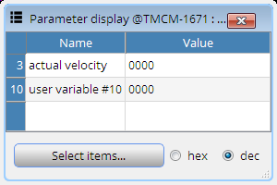
Figure 51: The Parameter Display
The contents of the displayed parameters can be presented in decimal or in hexadecimal form. This can be selected using the buttons at the bottom of the window. The displayed parameters are updated periodically, as fast as set up in the timer settings of the module connection. Clicking the Select button will show a dialog for selecting which parameters are to be displayed.

4.25 The Parameter Browser
The Parameter Browser is quite similar to the Parameter Display tool. But in contrast to the Parameter Display, it does not only display the contents of selected TMCL axis parameters and user variables, but also allows changing the values of the displayed parameters.
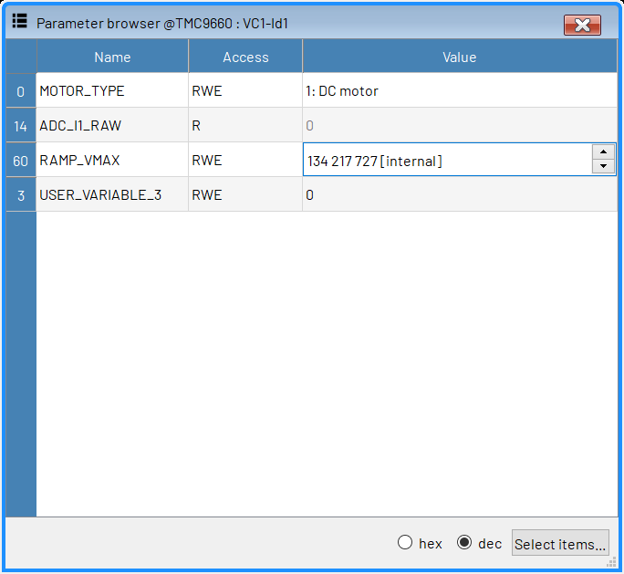
Figure 52: The Parameter Browser
The contents of the displayed parameters can be presented in decimal or in hexadecimal form. This can be selected using the buttons at the bottom of the window. The displayed parameters are updated periodically, as fast as set up in the timer settings of the module connection. Clicking the Select button will show a dialog for selecting which parameters are to be displayed. The Access column shows if a parameter is readable and/or writable using the following letters:
- R: parameter is readable
- W: parameter is writable
- E: parameter can be stored in the EEPROM of the module
- X: parameter can be saved using the Import/Export tool
The value of a parameter can be changed when it is writable. Click on the value to edit it. Press the return key to send the new value to the module.

4.26 PI tuning tool
For a smooth operation of the motor, an optimal set of P and I parameters are needed. The PI tuning tool is used for this purpose. The following sections describe how the PI tuning tool would work for torque, velocity and position mode. It is possible to perform tuning in both manual and auto mode however using auto mode is preferred. Before performing the PI tuning, it is important that the sensor connected is configured correctly.

4.26.1 Torque tuning
The PI tuning tool for torque can be seen in the figure 53. There is a possibility for performing the tuning both in the auto and manual modes. The target flux is changed by the Target field. The samples and sample rate can be changed from the settings tab on the right. It is not possible to change the P and I parameters in the auto mode but is possible in the manual mode.
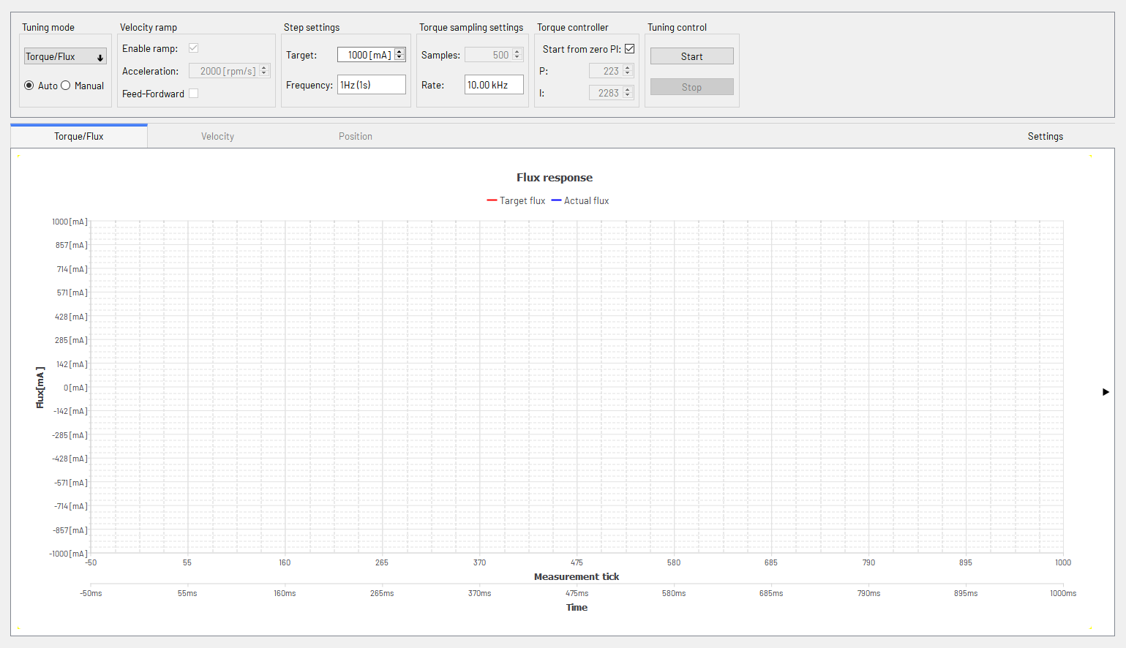
Figure 53: Torque tuning tool overview

4.26.1.1 Auto tuning
For performing PI tuning in the auto mode, the target flux is changed to a value at which the tuning is desired, normally this value should be not too high (relative to the motor rated current) and as a default it is set to 1000mA. Both P and I parameters are turned to 0 and the P parameter is increased such that the actual flux reaches 70% of the desired target flux. Once that is done, the I parameter is increased until the actual flux is as close to the desired flux as possible. Figure 54 shows the response of the target and actual flux once the tuning is completed:
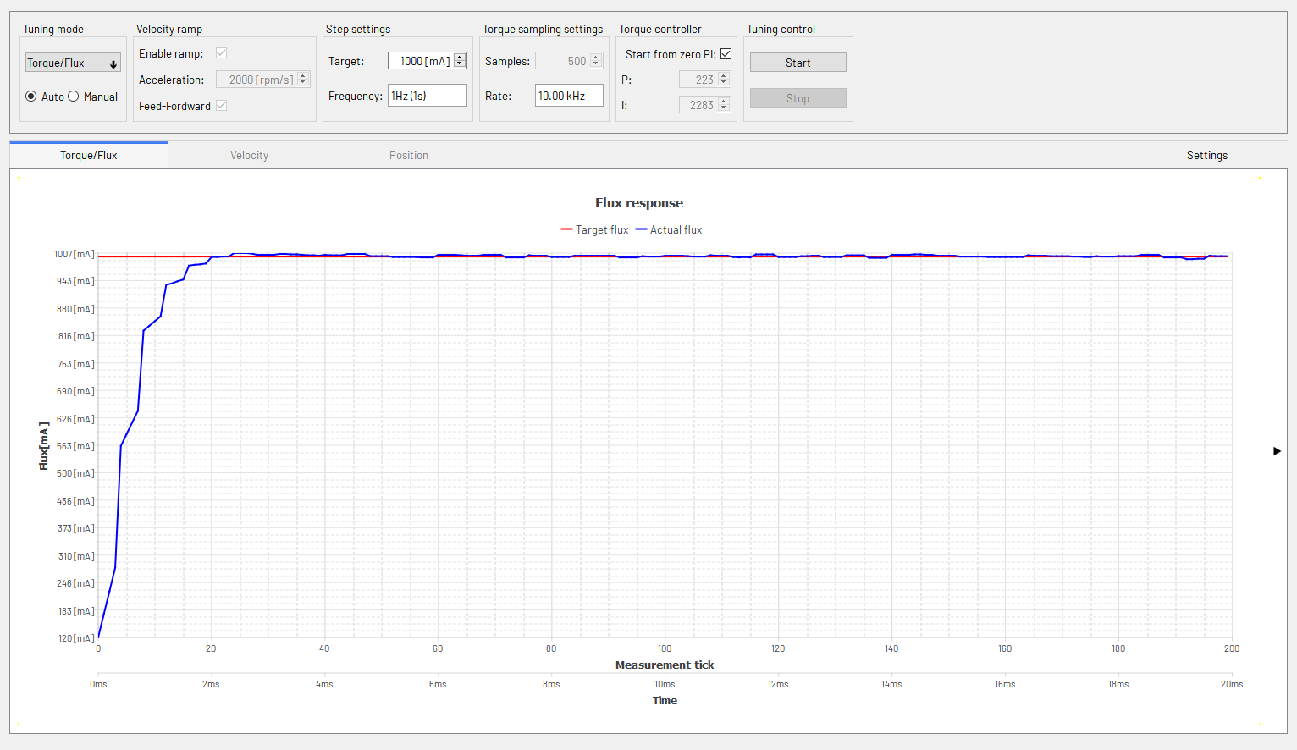
Figure 54: Automatic torque/flux tuning

4.26.1.2 Manual tuning
It is also possible to perform manual tuning with the tool. In manual continuous flux step responses are applied. The step response period can be set by the Frequency setting. Normally it is not used as often but can be helpful after auto tuning to further optimize the P and I parameters if necessary. It is also possible to perform the tuning in manual mode as well by following the same steps described in the auto mode. The target flux is set to the desired value and the P and I values can be changed manually until the desired response is achieved.
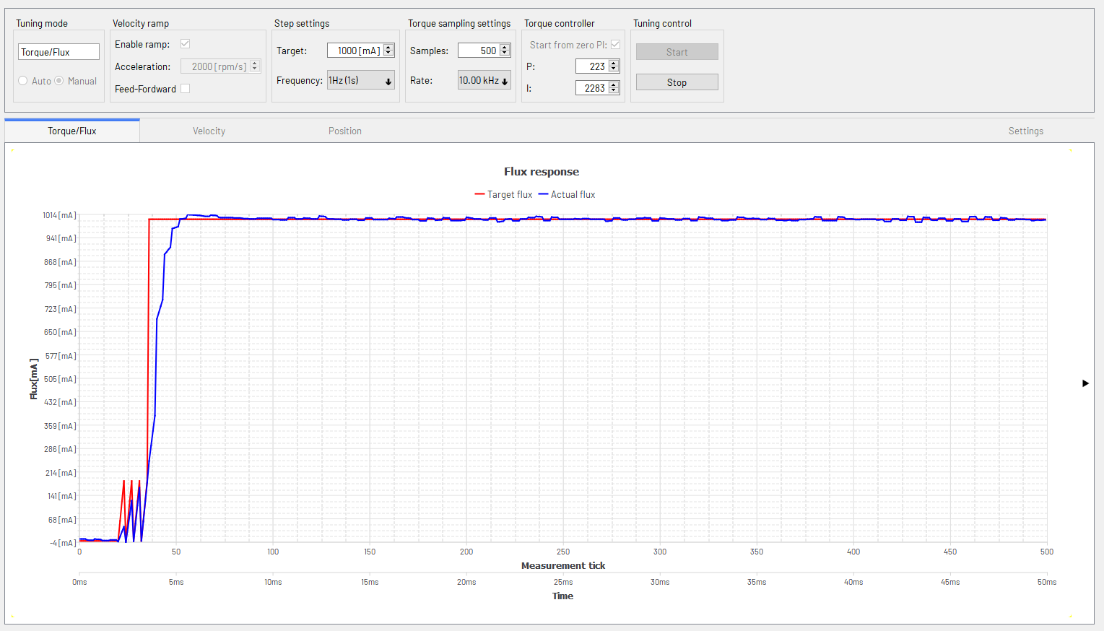
Figure 55: Manual torque/flux tuning

4.26.2 Velocity tuning
Figure 56 shows the overview of the tuning tool for velocity. The target velocity is changed by the Target field. Additionally, it is possible to enable/disable the ramp and the acceleration of the ramp. The samples and sample rate can be changed from the settings tab on the right. It is not possible to change the P and I parameters in the auto mode but is possible in the manual mode. Just like with torque/flux tuning, velocity tuning can be done both in auto and manual mode.
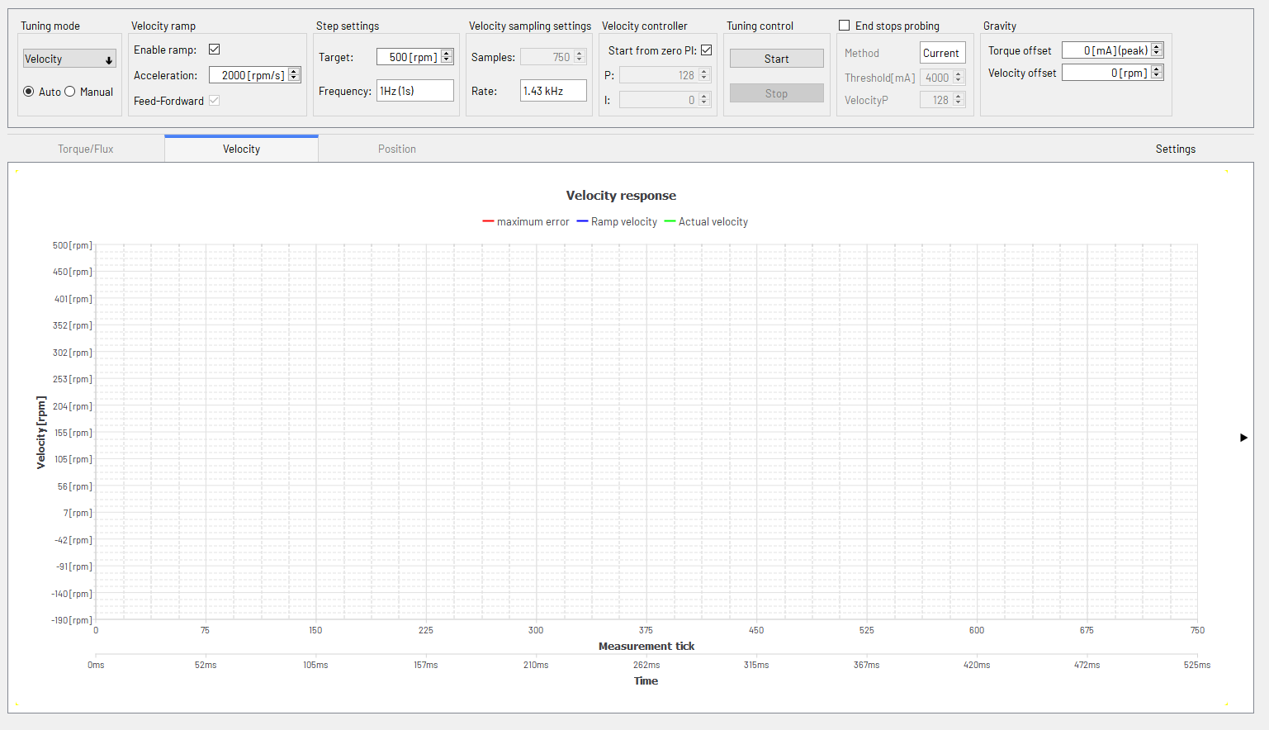
Figure 56: Velocity tuning tool overview

4.26.2.1 Auto tuning
First both the P and I parameters are set to 0. Then start the motor by setting in the target velocity in the Target field. P parameter will start to increase until the actual motor velocity reaches 80% of the target velocity. The rest of the difference is reduced by slowly incrementing the I parameter. The tool will indicate when the tuning is completed successfully. Figure 57 shows the target and actual velocity during the tuning process:
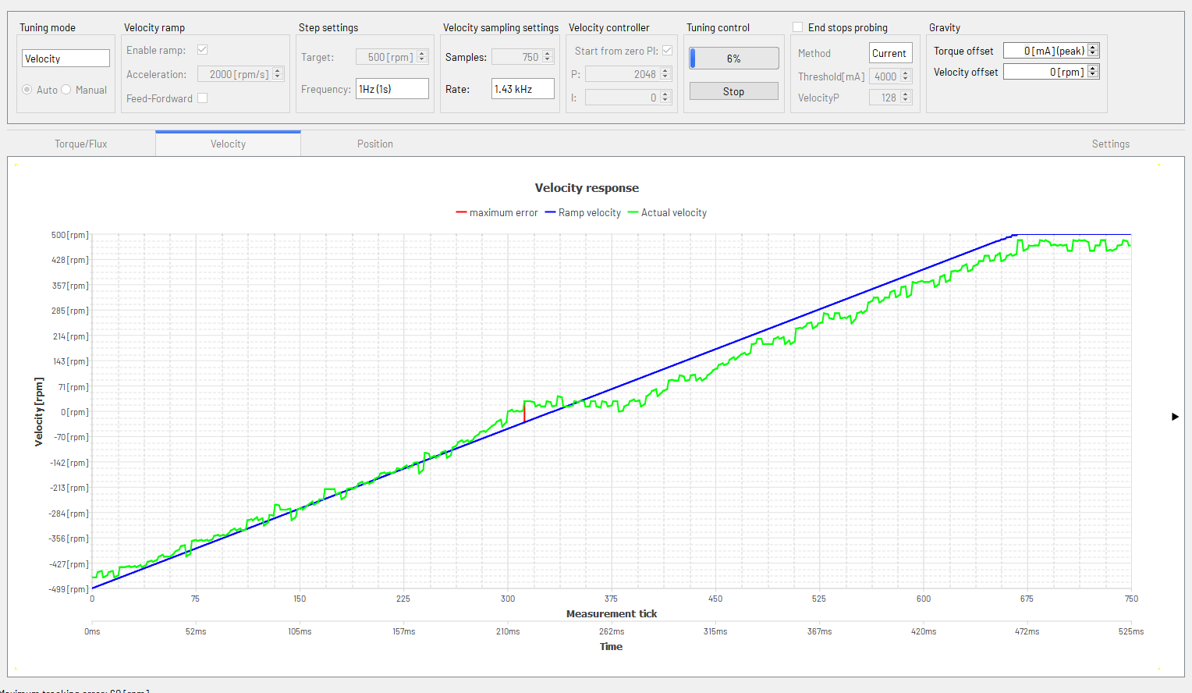
Figure 57: Automatic Velocity tuning

4.26.2.2 Manual tuning
It is also possible to perform manual tuning of velocity with the tool. The target velocity is set to the desired value and the P and I values can be changed manually until the desired response is achieved. For velocity mode in manual mode, the torque controller PI parameters can be adjusted as well.
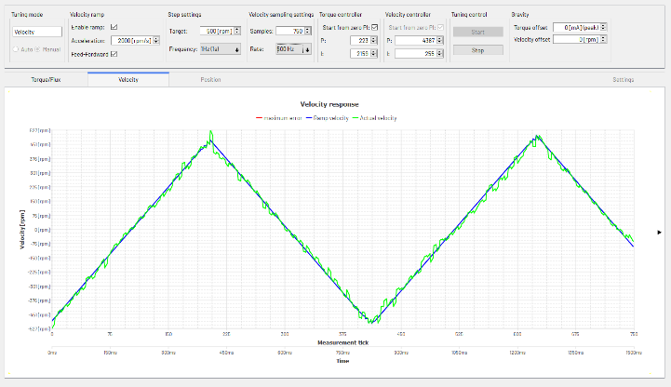
Figure 58: Manual Velocity tuning

4.26.3 Position tuning
The PI tuning tool for position can be seen in the figure below. Figure 59 shows the overview of the tuning tool for position. The target position is changed by the Target field. Unlike torque and velocity tuning, the position has only P parameter that needs to be tuned. It is to be noted that there is no units for position because normally its units are in steps and that is dependent on the resolution of the position sensor connected. Position tuning can also be done both in auto and manual modes as described below.
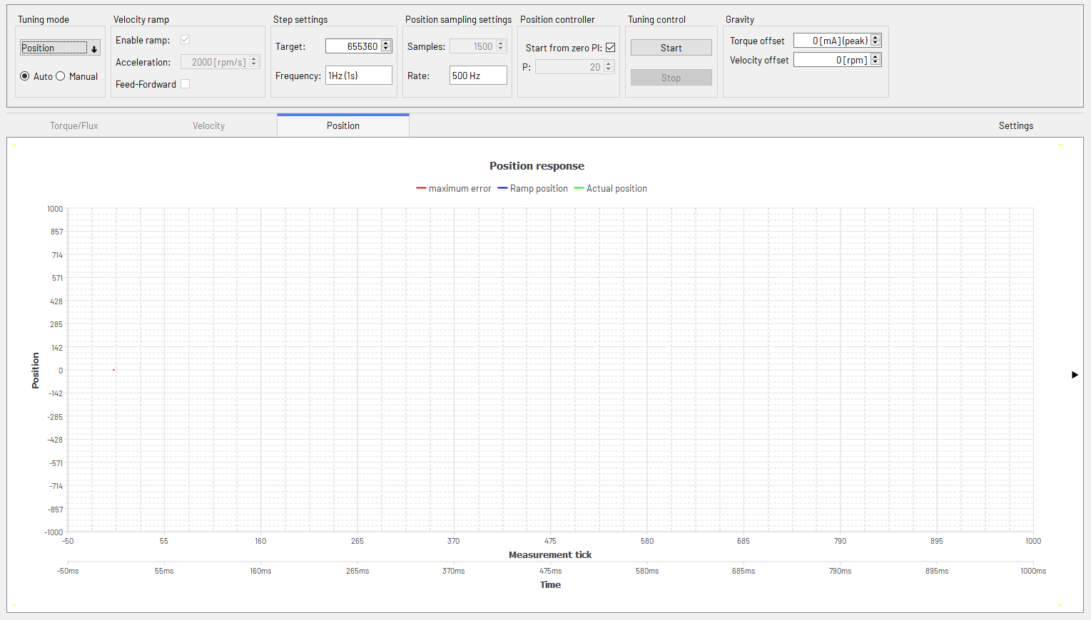
Figure 59: Position tuning tool overview

4.26.3.1 Auto Tuning
The target position is set at which the tuning is to be performed. When the Start button is pressed, the P parameter is increased until the actual position is as close to the target position as possible.
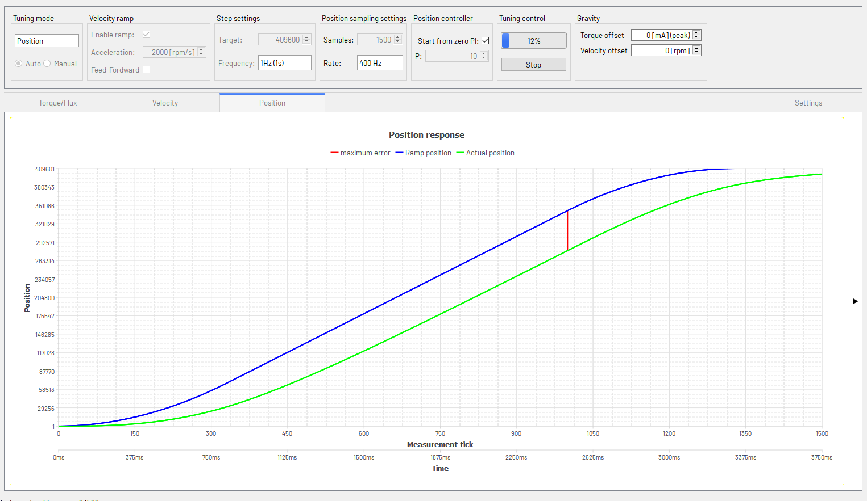
Figure 60: Automatic Position tuning

4.26.3.2 Manual tuning
It is also possible to perform manual tuning with the tool. The target position is set to the desired value and the P value can be changed manually until the desired response is achieved. For position mode in manual mode the torque controller and velocity controller PI parameters can be adjusted in addition to the position P parameter
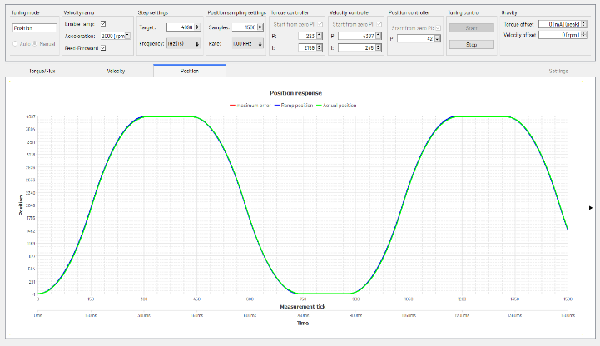
Figure 61: Manual Position tuning
In all auto tuning modes, the P and I parameters are set to 0 initially and then are increased to determine an optimal set of parameters. There is an option called Start from zero PI in all three modes. When it is enabled the algorithm will work as described above. However when it is not set, then the P and I parameters can be set to a certain value and the PI tuning will start from those values of P and I respectively.

5 Evaluation Board specific Tools
When an evaluation board (Landungsbruecke or Startrampe in conjunction with one or two chip evaluation boards) is connected, some special evaluation board tools will appear in the tree view. These tools are described in the sections of this chapter.
Some of the module specific tools are also used in conjunction with evaluation boards. These are for example tools like Direct Mode, Position Graph, Velocity Graph, Position Mode, Velocity Mode and also some more tools described in chapter 4. Please see also there.

5.1 The Main Evaluation Board Tool
Click on the Landungsbruecke or Startrampe entry in the tree view to open the main evaluation board tool. This tool provides some information about the connected evaluation board itself.
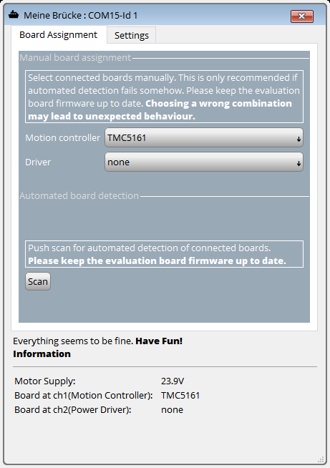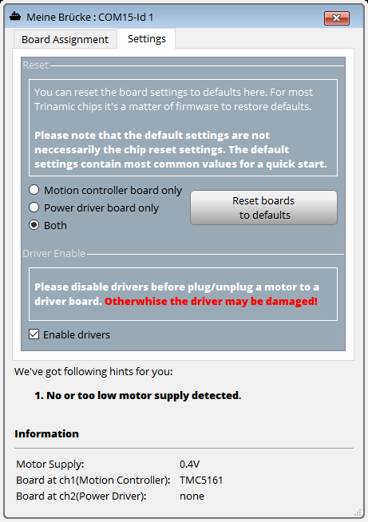
Figure 62: The Main Evaluation Board Tool

5.1.1 Board Assignment
On the Board Assignment tab, information about the evaluation boards connected to the Landungsbruecke or Startrampe board is shown. Under normal circumstances, the evaluation boards are detected automatically. If desired the automatic board detection can be re-started by clicking the Scan button.
If needed the connected evaluation boards can be set manually by picking them from the lists in the Manual Board Assignment section. Please note that setting the wrong boards may lead to unexpected behavior.

5.1.2 Settings
On the Settings tab you can reset the connected evaluation boards to their reset state and also switch the motor drivers on or off.

5.1.3 Diagnostics
The Diagnostics section shows common diagnostic messages about the connected board.

5.2 The Register Browser
The register browser is the most important tool for evaluating chips. With the help of this tool it is possible to look into all registers of a chip an also to change the contents of the registers. So all the functionality of a chip can be explored in detail.
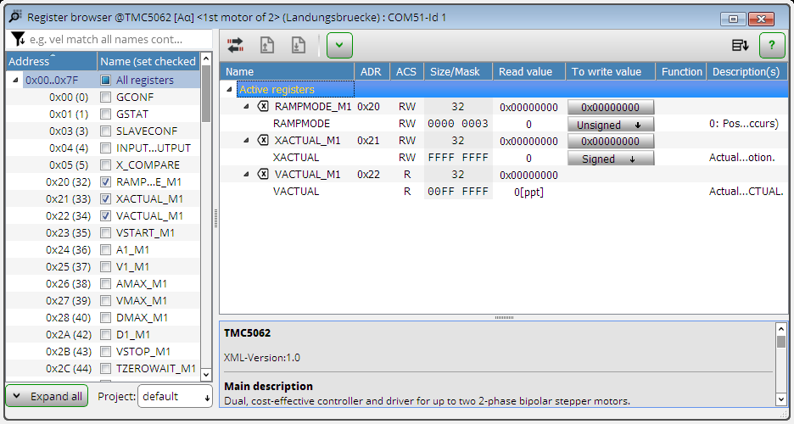
Figure 63: The Register Browser

5.2.1 Register List
On the left hand side of the register browser you can find a list of all registers. The registers are grouped together into functional groups. Click on a group to expand it and to show all registers that belong to that group. There is always also a group that contains all registers.
Check the checkbox of a register in the list to put it into the list of registers that are shown in the list of active registers.

5.2.2 Active Registers
In the center section of the register browser all register which are marked as active in the register list are shown. For every register there are the following entries:
- Name: The name of the register (same as in the chip datasheet). Click on the name to expand or to collapse the entry.
- ADR: The register address in the chip (same as in the chip datasheet).
- ACS: Shows how the register can be accessed. This can be R (read only), W (write only) or RW (read/write).
- Size/Mask: Shows the width of the register (in bits) and which bits can be accessed.
- Read value: Shows the contents of the register if this register is readable. This value is cyclically read from the chip and updated here.
- To Write value: The contents of registers that are writable are shown here. Click on a value to modify it. Then the value modification dialog will be shown:
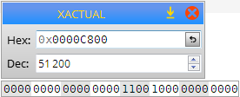
Figure 64: Changing a Register Value
Here you can enter the new value either as a decimal value or as a hexadecimal value. Press the ENTER key to send the new value to the chip.
- Function: This column shows the functionality of single bits in the register, like in the chip datasheet.
- Description: Contains the overall description of the register (like in the chip datasheet).

5.2.3 Utilities
The register browser also contains some utilities:
- Export/Import: The export/import utility can save the values of all writable registers in different format. All writable registers are shown in a list which can either be sorted by the register addresses or chronological by the time of the last write to the registers. This list can then be saved in different ways:
  - INI file: an INI file can also be read back by the export/import utility and written to the registers again.
  - TPC file: a TMCL/PC source code file will be generated which can then be used by the TMCL/PC host.
  - Send to TMCL/PC host: instead of writing to a file the TMCL/PC source code can also be directly sent to the TMCL/PC host.
  - Other options: Here the register contents can be save to a C/C++ file with different options.
Using the Import button an INI file can be read back and the values can be send to the registers. Click the Apply to Device button to send all registers contents to the chip.
- Generate a read command for the selected register and send this command to the TMCL/PC host.
- Generate a write command for the selected register and send this command to the TMCL/PC host.
- Read all registers at once.

5.3 The Flags View
Some chips are equipped with registers that provide flags. These are for example flags that represent the states of the end switches or the state of the ramp generator or error flags of a motor driver. Such flags are shown in the flag view. Depending on the structure of the flags they are grouped into different tabs.
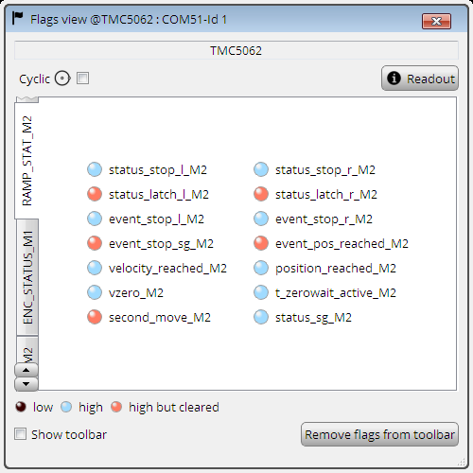
Figure 65: The Flags View
The flags view tool offers the following options:
- Cyclic: The flags view can either be updated automatically or manually. Check the Cyclic checkbox to switch on automatic update. If cyclic update is switched off then the flags view will not be updated automatically. In the this case click the Readout button to update the flags view.
- Show Toolbar: If this option is checked then flags can also be shown on a toolbar in the TMCL-IDE main window. You can then drag each flag to the toolbar. Clicking the Remove flags from Toolbar will remove all flags from the toolbar. Flags can also be dragged back from the toolbar to the flags view window.

5.4 The Chip-Click Tool
Some chips are equipped with input pins for configuring the functionality of the chip. These pins are normally directly connected to output pins of the Landungsbruecke or Startrampe board, so that their states can be set.
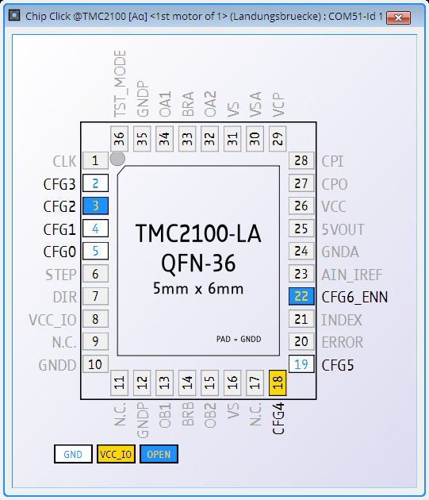
Figure 66: The Chip-Click Tool
The Chip-Click Tool is provided to set the states of those pins. The Chip-Click Tool shows all these pins on the footprint of the chip (as shown in the chip datasheet). Click on a pin to change between three possible states:
- GND : The pin is connected to ground and thus tied low.
- VCC_IO : The pin is connected to VCC_IO and thus pulled high.
- OPEN : The pin is unconnected an thus floating.

5.5 The Datagram Mode
The Datagram Mode is provided for all chips that are equipped with an SPI interface. It allows directly sending an SPI datagram to the connected chip.
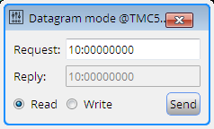
Figure 67: The Datagram Mode Tool
This tool provides the following functions:
- Request: Enter the datagram that you would like to send in hexadecimal form here. The first byte (separated from the rest by a colon) typically is the register address. The rest (four bytes) represents the contents to be sent. After you have entered the data click the Send button to send it to the chip.
- Reply: Most chips send a reply datagram via SPI. This reply datagram will be displayed here.
- Read / Write: Here you can choose if the datagram shall be sent in read mode or in write mode, i.e. if the read/write bit shall be set or not set. Please see the datasheet of the chip for details on SPI datagrams.

6 Container Tools
Tools that are not specific to a module or axis are called container tools. These are tools that can work with all supported modules. Some can also work with more than one module at a time. All the container tools can be found on the right hand side of the icon bar at the top of the main window.

6.1 The TMCL/PC Host
The TMCL/PC Host is a tool that can control one or more modules using a TMCL program that is being executed on the PC and not on the module. It also can be used to control evaluation boards (which do not support stand-alone TMCL programming) programmatically from the PC (which is sometimes needed for testing).
The language used by the TMCL/PC host is very similar to TMCL, but as the program is being executed on the PC it is called TMCL/PC. TMCL/PC is a dialect of TMCL that is executed on a PC as the host computer and is capable of controlling multiple Trinamic motion control modules and/or evaluation boards that are equipped with TMCL. Many commands are just put through to the modules, while other commands (for example branch commands) are executed directly on the host computer. Please see also the chapter about the syntax of TMCL/PC.
TMCL/PC programs can be developed and executed using the TMCL/PC host which is integrated into the TMCL-IDE as a container tool. The TMCL/PC host is not to be confused with the TMCL Creator.
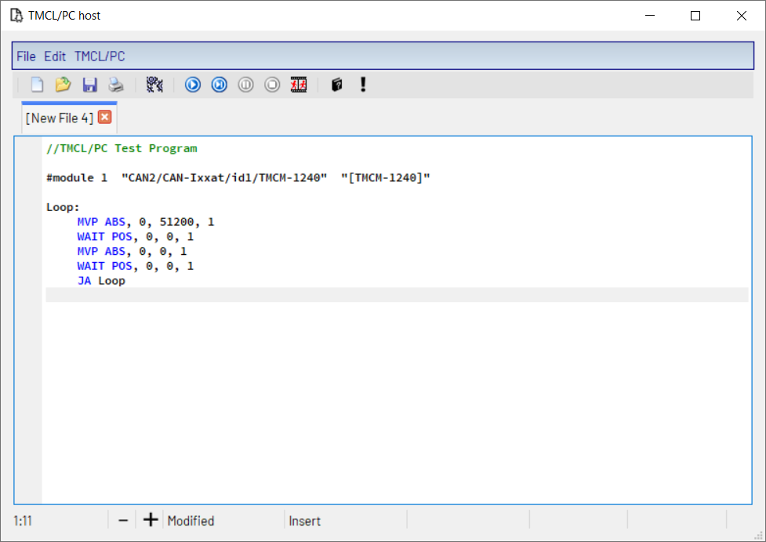
Figure 68: The TMCL/PC Host

6.1.1 The File Menu
The File menu of the TMCL Creator window provides the following functions:
- New: opens an empty editor tab for creating a new file.
- Open: loads a TMCL file into a new editor tab.
- Save: saves the content of the current editor tab to a file.
- Save as: saves the content of the current editor tab to a file using a new file name.
- Save all: saves all files that are currently loaded in the editor and that have been changed.
- Close: closes the currently open editor tab (same function as the close button of the editor tab).
- Print: print the content of the currently open editor tab.

6.1.2 The Edit Menu
The Edit menu provides standard text editor functions like Undo, Redo, Cut, Copy, Paste and a Find/Replace function. The Settings function opens a dialog where the text colors can be customized.
Figure 69: The Editor Settings Dialog

6.1.3 The TMCL/PC Menu
The TMCL/PC menu provides functions for assembling and executing TMCL programs as well as for setting some options of the TMCL/PC Host. These are the following functions:
- Assemble: Select Assemble from the TMCL/PC menu to assemble a file. If more than one file is open the currently selected file will be assembled. The process of the assembly is shown in a dialog (figure 70).
Figure 70: Progress of the TMCL/PC Assembly
- Run/Continue: After a program has been successfully assembled it can be executed. Before executing a program please make sure that all motion control modules that are used by the program are connected and powered. If a module does not respond to a command the program will be aborted with an error. This function is also used to continue the program after a breakpoint or after single stepping.
- Animate: This function automatically executes the TMCL/PC program step-by-step, so that the flow of the program can be seen. The actual position in the program is shown and updated after every command, and the contents of the accumulator and the X register are also shown on the status bar and updated after every command.
- Single Step: The Single Step function executes only the next command of a program. During single stepping, the next command to be executed is indicated by a green arrow on the left side of the editor. The contents of the local accumulator and the local X register are displayed on the status line at the bottom of the main window.
- Pause: The Pause function stops the execution of a running program, but the execution of the program can be continued by the Run/Continue function, the Single Step function or the Animate function.
- Stop: The Stop & Reset function stops the execution of a running program and resets the TMCL/PC interpreter. In this case the program cannot be continued, but it can be started again from the beginning using the Run function, the Single Step function or the Animate function.
- Local Variables: Choose Local Variables to open the Local Variables Window which can be used to inspect and to change the contents of TMCL/PC local variables.
- Remove all Breakpoints: This function removes all currently set breakpoints from the program.
- Options: The Options entry provides the following functions:
  - – Assembler/Debugger: Opens the Assembler/Debugger Options dialog.
  - – Module Assignments: Opens the Module Assignments dialog.

6.1.4 Breakpoints
For debugging purposes, breakpoints can be set. After a program has been successfully assembled, every line where a breakpoint can be set is indicated by a blue bullet on the left side of the editor. A breakpoint can be set by clicking on a blue bullet and is then indicated by a red bullet. A breakpoint can be removed by clicking on the red bullet again. The program execution will be stopped when the program reaches a breakpoint. It can then be continued by using the Run/Continue function, the Animate function or the Single Step function.

6.1.5 Assembler and Debugger Options
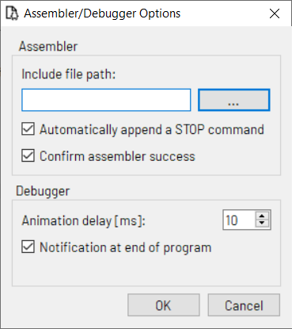
Figure 71: The TMCL/PC Options Dialog
In the Assembler/Debugger Options dialog the following options can be set:
- Include file path: The path used to search for include files included by the #include directive.
- Automatically append a STOP command: If this option is selected the assembler automatically appends a Stop command at the end of every TMCL/PC program (if the last command in the program is not already a STOP command).
- Confirm assembler success: If this option is selected then the assembler dialog will stay open after successful program assembly. With this option turned off the assembler dialog will be closed automatically on success. Beginners should leave this option switched on (default setting), while experts might want to turn it off.
- Animation delay: Additional delay between two instructions when using the Animate function.
- Notification at end of program: If this option is selected the user will be notified at the end of the TMCL/PC program.

6.1.6 Module Assignments
At the beginning of a TMCL/PC program, all connected modules and/or evaluation boards that are to be controlled by the program have to be defined using module assignment commands. The Module Assignments dialog helps defining these assignments as it is capable of generating these commands.
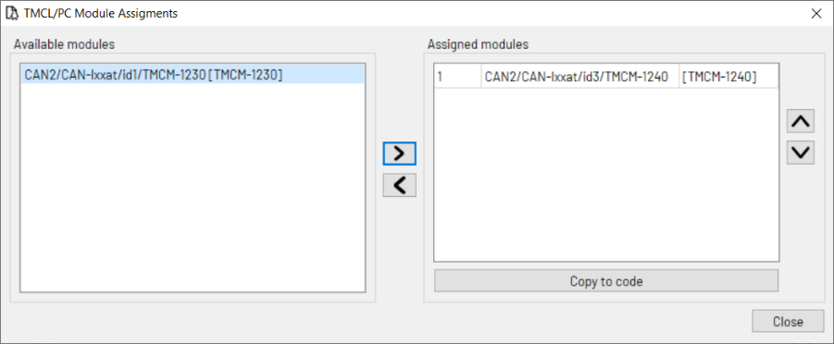
Figure 72: The Module Assignments Dialog
On the left side of the dialog, all available modules are shown. These are all modules and evaluation boards that are currently connected. Click on a module and then click the right arrow button or double click on a module to transfer it to the list of assigned modules.
On the right side of the dialog, all assigned modules are shown. Use the left arrow button to remove a module from the list of assigned modules (and to transfer it back to the list of available modules). Use the up and down arrow buttons to move an assigned module up and down on the list of assigned modules. Click on the index of a module to change its index, but take care not to assign the same index more than once. Mostly it is not necessary to change the module indices.
Finally, click the Copy to code button to generate the module assignment commands. These will be copied to the currently active editor page of the TMCL/PC host.

6.1.7 The Local Variables Window
The Local Variables Window provides functions for inspecting and changing the contents of the TMCL/PC local variables. It is a non-modal window that can be used together with the TMCL/PC main window.
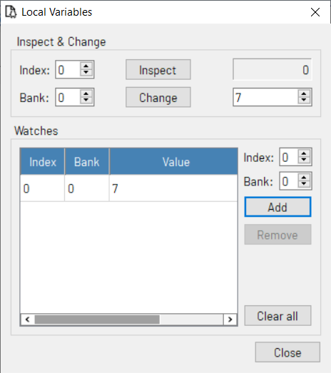
Figure 73: The Local Variables Window
Using the Inspect & Change section, the contents of local TMCL/PC variables can be inspected and also changed. First, enter the bank and the index of a local variable. Then, click the Inspect button to display its contents. The value will then be displayed on the right hand side beneath the Inspect button. To change its contents, enter a new value in the input field on the right hand side beneath the Change button. Then click the Change button, and the new value will be copied to the variable defined by the Index and Bank value.
Using the Watches section the contents of selectable local variable can also be displayed. The display will be updated whenever a TMCL/PC local variable gets changed during execution of a TMCL/PC program. This way it is possible to automatically watch the contents of local variables which can be very useful for debugging a TMCL/PC program. Enter the index and the bank number of a local variable and then click the Add button to add it to the list of watches. The Remove button can be used to remove a local variable from the watch list. The Clear all button clears the entire list of watches.

6.2 The Firmware Update Tool
The Firmware Update Tool provides the functionality for updating the firmware of TRINAMIC motor control modules and evaluation boards.
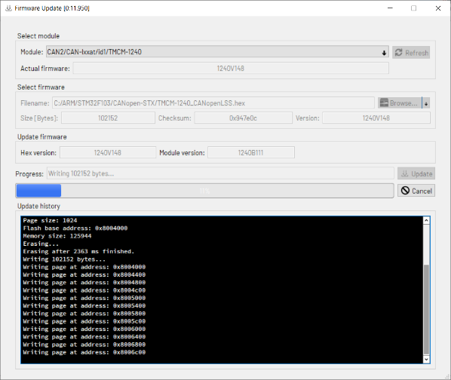
Figure 74: The Firmware Update Tool

6.2.1 Select Module
In the Select Module section all connected modules are shown in a list. If another module has been connected while the Firmware Update Tool is open press the Refresh button to refresh the list of available modules.
Select the module that is to be updated. After picking a module from the list, its actual firmware version will be displayed in the Actual firmware field.

6.2.2 Select Firmware
In the Select Firmware section you can select the firmware file to be downloaded to the module. Click the Browse button and select the desired firmware file. If the file is a valid firmware file then its size, check sum and version will be shown.

6.2.3 Update Firmware
Click the Update button to start the update process. The progress will be shown by the progress bar. The update history shows details of the upgrade process. This normally is only relevant if the update should go wrong, so that TRINAMIC can analyze the problem.

6.2.4 Hints for Firmware Updates
Here are some additional hints for firmware updates, especially for the case that updating the firmware should not work as expected.

6.2.4.1 Which Interface to choose?
With most modules, all interfaces the module is equipped with can also be used for firmware updates. So, firmware updates can take place via USB, RS232, RS485 or CAN. If the module is equipped with an USB interface then this is mostly the easiest way for updating the firmware. When using RS485 it is often necessary that only the module that is to be updated is connected to the RS485 bus, so disconnect all other modules if problems should occur during firmware update.
For modules that are only equipped with a CAN interface and that are used with CANopen firmware, it is necessary to switch them into boot loader mode using the CANopen tab of the Connection window prior to using the Firmware Update Tool.

6.2.4.2 What if the Update Process has been aborted?
If anything should go wrong and the update process has been aborted, you can just try again. Power cycle the module (when using USB, also disconnect and then re-connect the USB cable) and also re-start the TMCL-IDE. Mostly the module is in bootloader mode then. It will be shown as module in bootloader mode in the tree view then.
When using RS232 or RS485 you will have to switch the baudrate in the connection window to 115200 before clicking the Connect button, as in bootloader mode the baud rate is always 115200, the module ID is always 1 and the reply ID is always 2.
When using CAN in bootloader mode, the bit rate is always 1000kBit/s, the module CAN ID is always 1 and the reply ID is always 2.

6.2.4.3 Old modules
Very old TRINAMIC modules (most of them (except for the TMCM-110) are not supported by the TMCL-IDE 3.x and 4.x) use a different boot loader protocol. This is not supported by the Firmware Update Tool. In this case the firmware update will not be possible. For such old modules, use the TMCL-IDE 2.x to perform the firmware update. The TMCL-IDE 2.x can be downloaded as "Legacy IDE" from the TRINAMIC website.

7 Wizards
The TMCL-IDE also provides tools that guide the user step by step through some more complex functions and setup processes of a module or a chip evaluation board. These kind of tools are called wizards. To use a wizard, first click the wizard icon on the tool bar to open the wizard selection window.
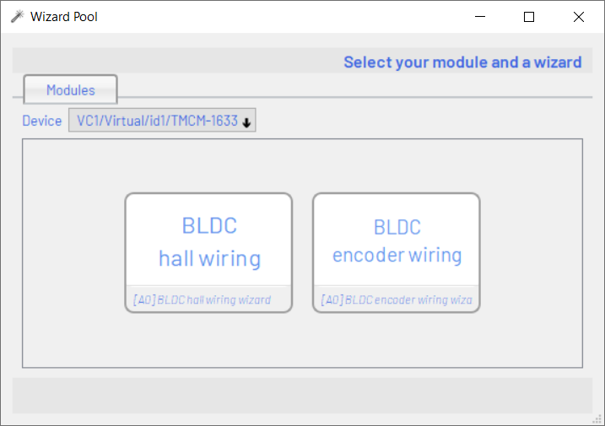
Figure 75: The Wizard Window
Here, one of the connected modules can be chosen. Depending on the module, all wizards supporting this module are shown. Now you can choose a wizard. Then you can go through it step-by-step. As all explanations are contained in the wizard itself the wizards are not described in detail here.
Here is a list of all wizards that are available in the current version of the TMCL-IDE:
- stallGuard2 Wizard
- coolStep Wizard
- Chopper Wizard
- dcStep Wizard
- Microstep Calibration Wizard
- BLDC Hall Wiring Wizard
- BLDC Encoder Tuning Wizard
- BLDC PID Tuning Wizard
- Weasel Configurator Wizard
- ESI Configurator Wizard

8 The Syntax of TMCL
This section defines the syntax of the TMCL commands used in the TMCL Creator. Please see the TMCL Firmware Manual of your module for further explanations concerning the functionality of all TMCL commands that your module supports. The command mnemonics given there are used in the TMCL Creator.
Please see also the sample program files that are available on the TRINAMIC website.

8.1 Assembler Directives
An assembler directive starts with the # sign, and the only directive is #include to include a file. The name of that file must be given after the #include directive. If this file has already been loaded into the editor then it will be taken from there. Otherwise it will be loaded from file, using the include file path that can be set in the Options dialogue of the TMCL Creator.

Example
#include test.tmc

8.2 Symbolic Constants
Symbolic constants are defined using the following syntax:
<Name> = <Value>
A Name must always start with a letter or the sign _ and may then contain any combination of letters, numbers and the sign _.
A Value must always be a decimal, hexadecimal or binary number or a constant expression. Hexadecimal numbers start with a $ sign, binary numbers start with a % sign.

Example
1 Speed =1000
Speed2 = Speed /2
3 Mask = $FF
Binary Value =%1010101

8.3 Constant Expressions
Wherever a numerical value is needed, it can also be calculated during assembly. For this purpose constant expressions can be used. A constant expression is just a formula that evaluates to a constant value.
The syntax is very similar to BASIC or other programming languages. Table 3 shows all functions and table 4 shows all operators that can be used in constant expressions.
The calculation takes place during compile time and not during runtime.
Internally, the assembler uses floating point arithmetic to evaluate a constant expression, but as TMCL commands only take integer values, the result of a constant expression will always be rounded to an integer value when being used as an argument to a TMCL command.

 | Functions in Constant Expressions
Name | Function
SIN | Sinus
COS | Cosinus
TAN | Tangens
ASIN | Arcus Sinus
ACOS | Arcus Cosinus
ATAN | Arcus Tangens
LOG | Logarithm Base 10
LD | Logarithm Base 2
LN | Logarithm Base e
EXP | Power to Base e
SQRT | Square root
CBRT | Cubic root
ABS | Absolute value
INT | Integer (truncate)
ROUND | Integer (Round)
CEIL | Round upward
FLOOR | Round downward
SIGN | -1 if argument<1  - if argument=0  - if argument>0
DEG | Converts from radiant to degrees
RAD | Converts from degrees to radiant
SINH | Sinus hyperbolicus
COSH | Cosinus hyperbolicus
TANH | Tangens hyperbolicus
ASINH | Arcus sinus hyperbolicus
ACOSH | Arcus cosinus hyperbolicus
ATANH | Arcus tangens hyperbolicus
Table 3: Functions in Constant Expressions

 | Operators in Constant Expressions
Operator | Function
() | Parenthesis
Operator | Function
ˆ | Power
* | Multiply
/ | Divide
\ | Modulo
+ | Add
- | Subtract
Table 4: Operators in Constant Expressions
Symbolic constants, floating point numbers, integer numbers, hexadecimal numbers and binary numbers can also be used in constant expressions.

Example
ROL 0, 7+9*8
2 Speed2 = Speed * SIN (0.5)
MVP ABS , 0, 3*1000
4 Sin90 = Sin ( Rad (90) )

8.4 Labels
The form used for labels is:
<Name>:
For names of labels the same rules as for names of symbolic constants apply.

Example
Loop : MVP ABS , 0, 1000
2 WAIT POS , 0, 0
MVP ABS , 0, 0
4 WAIT POS , 0, 0
JA Loop

8.5 Comments
Comments always start with // (like in C++). The rest of the line will then be ignored.

8.6 TMCL Commands
Please see the TMCL Firmware Manual of your module for detailed explanations of all commands sup-ported by the specific module.

9 The Syntax of TMCL/PC
The syntax of TMCL/PC is very similar to the syntax of TMCL. Please see also chapter 8 for details. Most things defined there also apply for TMCL/PC. In this chapter we assume that the reader is already familiar with TMCL, and only the differences between TMCL/PC and TMCL are pointed out.

9.1 Module Index Parameter
All commands that are directly put through to the modules have an additional module index parameter. This is to specify on which of the connected modules the command shall be executed. The module index parameter is the last parameter of the command. The module indices must be defined using the #module directive. Here is a list of all commands that use the additional module index parameter:
- ROL <motor>,<velocity>,<module index>
- ROR <motor>,<velocity>,<module index>
- MST <motor>, <module index>
- MVP <ABS|REL|COORD>, <motor>, <position>, <module index>
- SAP <type>, <motor>,<value>, <module index>
- GAP <type>, <motor>,<module index>
- STAP <type>, <motor>, <module index>
- RSAP <type>, <motor>, <module index>
- SGP <type>, <bank>, <value>, <module index>
- GGP <type>, <bank>, <module index>
- STGP <type>, <bank>, <module index>
- RSGP <type>, <bank>, <module index>
- RFS <START|STOP|STATUS>, <motor>, <module index>
- SIO <type>, <bank>, <value>, <module index>
- GIO <type>, <bank>, <module index>
- SCO <type>, <motor>, <value>, <module index>
- GCO <type>, <motor>, <module index>
- CCO <type>, <motor>, <module index>
- SAC <type>, <bank>, <value>, <module index>
- UF0 <type>, <motor>, <value>, <module index>
- UF1 <type>, <motor>, <value>, <module index>
- UF2 <type>, <motor>, <value>, <module index>
- UF3 <type>, <motor>, <value>, <module index>
- UF4 <type>, <motor>, <value>, <module index>
- UF5 <type>, <motor>, <value>, <module index>
- UF6 <type>, <motor>, <value>, <module index>
- UF7 <type>, <motor>, <value>, <module index>
- WAIT <POS|RFS|REFSW|LIMSW>, <motor>, <timeout [ms]>, <module index>
- ROLA <motor>, <module index>
- RORA <motor>, <module index>
- MVPA <ABS|REL>, <module index>

9.2 Module Index Definition
The module indices are defined using the #module directive. A module index can be any number between 1 and 255. The #module directive has two parameters: the module index that is to be defined and the key of the module that is to be assigned to this module index. Optionally the alias name of the module can also be supplied as a third parameter (in brackets). The names can be put into double quotes. This is necessary if the names contain spaces. In other cases, the double quotes can be left out, but we recommend to use them. So the module definitions can look like this:
1 # module 3 " COM2 / Serial / id1 / TMCM -1140 " "[ TMCM_1140 ]"
# module 1 " COM54 / USB / id1 / TMCM -1161 " "[ TMCM_1161 ]"
Then, commands can use module index 1 and module index 3, like this:
MVP ABS , 0, 51200 , 1
2 MVP REL , 0, 1000 , 3
There is also a tool that can generate the module definitions: Just choose Options/Module definitions in the TMCL/PC menu to display the Module Assignment Dialog. There you can put together the module definitions and copy them into your TMCL/PC program.

9.3 Local Commands
All other TMCL commands are executed locally in the TMCL/PC interpreter. The TMCL/PC interpreter also has a local accumulator register, a local X register and local TMCL flags. The results of the GAP, GGP, GIO, GCO and SAC commands are copied into the local accumulator register. The following TMCL commands are executed locally and and work with the contents of the local accumulator register or local X register or local TMCL flags:
- COMP <value>
- CALC <type>, <value>
- CALCX <type>
- CALCV <type>, <index>, <value>
- CALCVA <type>, <index>
- CALCAV <type>, <index>
- CALCVX <type>, <index>
- CALCXV <type>, <index>
- CALCVV <type>, <index0>, <index1>
- JC <condition>, <label>
- JA <label>
- DJNZ <index>, <label>
- CSUB <label>
- RSUB
- CALL <condition>, <label>
- RST <label>
- WAIT TICKS, 0, <time [ms]>
- STOP
- CLE <flags>
- AAP <type>, <axis>, <module index> (Copies the contents of the local accumulator to an axis parameter of a module.)
- AGP <type>, <axis>, <module index> (Copies the contents of the local accumulator to a global parameter of a module.)
Please note that the commands AAP and AGP are special cases: they are executed locally, but change a value in on module with the given module index. In fact, an SAP command respective an SGP command will be generated internally for the module. The calculation commands that use variables and the DJNZ command work on the local variables in bank 0.

9.4 Local Variables
The TMCL/PC interpreter provides an array of local variables for storing values locally. There are 256 banks of local variables, and each bank provides 256 local variables. For using these local variables, some special commands are provided:
- STOA <index>, <bank>: stores the contents of the local accumulator to the local variable specified by <index> and <bank>.
- STOX <index>, <bank>: stores the contents of the local X register to the local variable specified by <index> and <bank>.
- RCLA <index>, <bank>: copies the contents of the local variable specified by <index> and <bank> to the local accumulator.
- RCLX <index>, <bank>: copies the contents of the local variable specified by <index> and <bank> to the local X register.
- SETV <index>, <bank>, <value>: Initializes the local variable specified by <index> and <bank> with the value specified by <value>.
The range of the <index> and <bank> parameters is 0. . . 255. The contents of local variables can also be displayed for debugging purposes using the Local Variables Window.

9.5 Evaluation Board Commands
There are also some special commands for using Trinamic evaluation boards (combinations of Startrampe or Landungsbruecke with other chip evaluation boards). These are the following commands:
- UFMC <type>, <motor>, <value>, <module index>: special UF command for the motor controller connected to the Startrampe/Landungsbruecke.
- UFDRV <type>, <motor>, <value>, <module index>: special UF command for the motor driver connected to the Startrampe/Landungsbruecke.
- WMC <register>, <upper>, <value>, <module index>: write to a motion controller register. Always set the parameter <upper> to 0 when writing to registers of up to 32 bits width. When writing to a 64 bit register, two WMC commands are needed. Always write to the lower 32 bits first with <upper> set to 0 and then write the upper 32 bits with <upper> set to 255.
- WDRV <register>, <upper>, <value>, <module index>: write to a motor driver register. Always set the parameter <upper> to 0 when writing to registers of up to 32 bits width. When writing to a 64 bit register, two WDRV commands are needed. Always write to the lower 32 bits first with <upper> set to 0 and then write the upper 32 bits with <upper> set to 255.
- RMC <register>, <upper>, <module index>: read from a motion controller register. Always set the parameter <upper> to 0 when reading from registers of up to 32 bits width. When reading from a 64 bit register two RMC commands are needed. First, read the lower 32 bits with the parameter <upper> set to 0 and then read the upper 32 bits with <upper> set to 255.
- RDRV <register>, <upper>, <module index>: read from a motor driver register. For Always set the parameter <upper> to 0 when reading from registers of up to 32 bits width. When reading from a 64 bit register two RDRV commands are needed. First, read the lower 32 bits with the parameter <upper> set to 0 and then read the upper 32 bits with <upper> set to 255.
- WMCA <register>, <upper>, <module index>: copy contents of the accumulator to a motion controller register. Always set the parameter <upper> to 0 when writing to registers of up to 32 bits width. When writing to a 64 bit register, two WMCA commands are needed. Always write to the lower 32 bits first with <upper> set to 0 and then write the upper 32 bits with <upper> set to 255. It is strongly recommended to use this command only for registers of up to 32 bits width.
- WDRVA <type>, <register>, <module index>: copy contents of the accumulator to a motor driver register. Always set the parameter <upper> to 0 when writing to registers of up to 32 bits width. When writing to a 64 bit register, two WDRVA commands are needed. Always write to the lower 32 bits first with <upper> set to 0 and then write the upper 32 bits with <upper> set to 255. It is strongly recommended to use this command only for registers of up to 32 bits width.

10 CANopen
For many TRINAMIC modules also a CANopen firmware is available. These modules can then also be used with the CANopen protocol instead of the TMCL protocol. To have a unique tool for both protocols, the CANopen tools have also been integrated into the TMCL-IDE. Using these, handling modules that use the CANopen protocol will be nearly as easy as using TMCL. Many tools from the TMCL section can also be used with CANopen. Furthermore, the TMCL-IDE also contains some CANopen specific tools.

10.1 CANopen Connection
For connecting to the CAN bus, a CAN interface is needed. All CAN interfaces that are supported by the TMCL-IDE can also be used for CANopen connections. Table 1 and table 2 list the supported CAN inter-faces. Maybe other CAN interfaces from the same manufacturers will also work with the TMCL-IDE, but have not been tested by Trinamic.
All supported CAN interfaces are shown in the tree view on the left hand side of the main window. For each CAN interface a TMCL CAN connection and a CANopen connection is shown in the tree view. Click on the CANopen connection to open the CANopen connection window for the desired CAN interface.
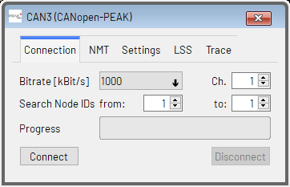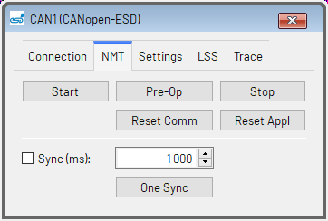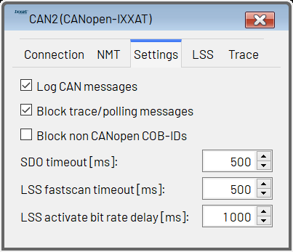
Figure 76: The CANopen Connection Window

10.1.1 Connection
Use the Connection tab to make general settings for the connection and to connect to your devices attached to the CAN bus. The following options are available:
- Bitrate: Select the desired CAN bit rate here. The factory default setting on most Trinamic modules is 1000kBit/s. Change this if you have set up your module to use a different bit rate.
- Search Node IDs from/to: It is possible to connect more than one module to a CAN bus. For this reason, the TMCL-IDE can search for more than one module on the CAN bus. Enter the node ID of the first module connected to the bus and the node ID of the last module connected to the bus here. If only one module is connected you can normally leave both values at 1, as this is also the factory default setting on Trinamic modules. Or if the module is set to a different ID, set both values to that ID. If you are not sure about the ID setting of a module you can also enter from 1 to 127 so that the TMCL-IDE will automatically scan through all possible CANopen node IDs, but this will take some time.
- Ch. (Channel): Some CAN interfaces are equipped with more than one CAN port. In such a case the Channel entry will be shown. The port to be used can be specified there. For CAN interfaces that are equipped with only one port (which is the case for most CAN interfaces) this setting will not be shown.
- Connect: Click the Connect button to open the connection and to start searching for modules connected to the CAN bus. The search progress will be shown by the progress indicator. All modules that have been found will appear on the tree view on the left hand side of the main window.
- Disconnect: Click here to close the connection.

10.1.2 NMT
Use the NMT tab to send NMT commands to all devices connected to the CANopen network. The following NMT commands are available:
- Start: Issues an NMT Start command for all modules connected to the bus.
- Pre-Op: Issues an NMT Pre-Op command for all modules connected to the bus.
- Stop: Issues an NMT Stop command for all modules connected to the bus.
- Reset Comm: Issues an NMT Reset Communication command for all modules connected to the bus.
- Reset Appl: Issues an NMT Reset Application command for all modules connected to the bus.
- Sync (ms): When the Sync (ms) checkbox is switched on, SYNC commands will be sent periodically. The time between two SYNC commands can also be set here.
- One Sync: Sends just one SYNC command on the CAN bus.

10.1.3 Settings
Use the Settings tab of the CAN connection window to control some general settings:
- Log CAN messages: This checkbox switches on or off CAN message logging for this port. When switched on (default setting), all CAN messages sent and received on this CAN port will be shown in the Log window.
- Block trace/polling messages: Some tools in TMCM-CANopen use polling of specific objects by SDO on a regular base. When this checkbox is checked, SDO messages generated for tracing/polling CANopen objects will not be shown in the log window.
- Block non-CANopen COB-IDs: When checked, all CAN messages with a COB-ID that does not belong to the CANopen standard COB-ID set will not be shown in the log window and will also not be further processed by the CANopen tools. This way, other non-CANopen traffic on the same bus (for example TMCL messages) can be masked out from the CANopen tools.
- SDO timeout: This is the timeout value for SDO communication. When accessing an object via SDO communication the module has to answer within this time. Otherwise an error message will be shown. Mostly the default value of 500ms is sufficient, but there may be cases where this timeout value has to be set higher.
- LSS fastscan timeout: This is the timeout value needed for the LSS fastscan algorithm. The default value is 500ms. When many devices are connected or with devices that respond slower, a higher value will be needed. When only a few devices are connected that have a short response time also lower values can be used.
- LSS activate bitrate delay: Sets the delay which is used with the LSS activate bitrate command (for single devices as well as for the entire network).

10.1.4 LSS
The LSS tab provides support for the CANopen Layer Setting Service (LSS). With devices that support LSS the node ID and bit rate can be set using these functions. In the Network section, network wide LSS functions are provided.
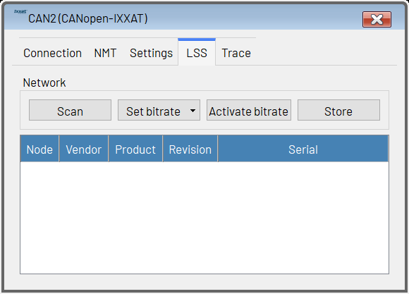
Figure 77: The LSS tab (with empty LSS device list)
- Scan: Clicking this button erases the list of LSS devices and starts an LSS fastscan. All connected devices that support fastscan and that are in unconfigured (LSS Waiting) state will be found and shown in the list of LSS devices. Depending on the number of unconfigured devices and the LSS fastscan timeout setting the LSS fastscan process can take some time (at least 33·LSSf astscan_timeout). Setting the LSS fastscan timeout to a lower value accelerates this process. But be careful, as with a too low timeout setting some unconfigured LSS devices might not be found.
- Set bitrate: This button opens a menu for choosing the CAN bit rate setting of all connected LSS devices. The new setting will not be activated, nor will the bit rate used by the TMCL-IDE be changed.
- Activate bitrate: This will send an LSS activate bitrate command to all LSS devices. The delay entered in the LSS activate bitrate delay setting will be used. After the end of this delay time all connected LSS devices will be using the new bitrate setting. Again, this will not change the bitrate used by the TMCL-IDE.
- Store: All connected LSS devices will store their new node ID and bitrate settings permanently.
Clicking the right mouse button over the list of LSS modules brings up a context menu containing functions for individual devices. It also offers the possibility to add devices to the list that are already configured, so that their node ID and bitrate settings can also be changed.
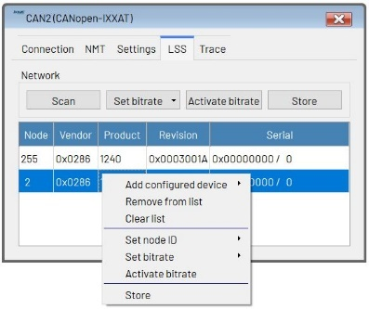
Figure 78: The LSS device list contains two LSS devices and showing its context menu
- Add configured device: Use this function to add a configured device to the list of LSS modules. In the submenu, just enter its node ID and press the return key. It will then appear in the list.
- Remove device: Removes the currently selected device from the list.
- Clear list: Clears the entire LSS device list.
- Set node ID: This function changes the node ID of the currently selected device. In the submenu, enter the new node ID and press the return key. The node ID of that device will then be changed (but the setting will not be stored permanently in the device).
- Set bitrate: Use this to change the bitrate of the currently selected device. Choose the new bitrate from the submenu. The new bitrate will be set but will not be activated on the device.
- Activate bitrate: Activates the new bitrate setting on the currently selected device only. The LSS bitrate activation delay will be used. Use with care as this can lead to the fact that one device uses a different bitrate than the other devices.
- Store: Any changes made to the node ID and/or bitrate settings of the selected device will be stored permanently in its non-volatile memory.

10.1.5 Trace
Some of the tools need to regularly poll values from the module. This is being done by continuously reading objects via SDO. The Trace tab shows all CANopen objects that are continuously read by the TMCL-IDE. Using the Stop and the Start button the continuous polling of CANopen objects can be stopped and started. Also the time interval between two regular reads of objects can be changed here. Under normal circumstances it is not necessary to make changes here.
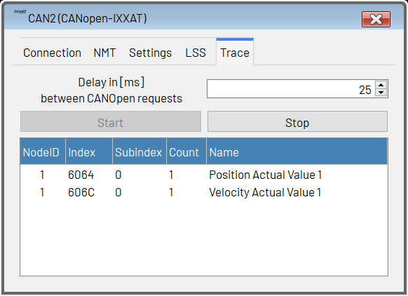
Figure 79: The Trace tab

10.2 EDS Files

10.2.1 About EDS Files
In order to be able to work properly with a CANopen device, the TMCL-IDE needs to have some knowledge of its CANopen object dictionary and its other capabilities. For this purpose, EDS (electronic data sheet) files are used. For every CANopen device, an EDS file is provided by its vendor. Thus, also for each Trinamic CANopen module an EDS file is provided on the Trinamic website.

10.2.2 EDS Files for Trinamic Modules
The EDS files for all Trinamic CANopen modules are already integrated into the TMCL-IDE, so one does not have to care about this. Only if for example a newer firmware version for a specific module is provided by Trinamic it might be necessary to integrate the newer EDS file into the TMCL-IDE. The same will also be necessary when devices of other vendors are to be used with the CANopen specific tools of the TMCL-IDE.

10.2.3 Integrating EDS Files into the TMCL-IDE
Other EDS files (that can either be newer EDS files from Trinamic or EDS files from other manufacturers) can be integrated into the TMCL-IDE as follows:
- Open the directory that contains the TMCL-IDE.
- Here, a directory called UserEds can be found.
- Copy the new EDS files into the UserEds directory.
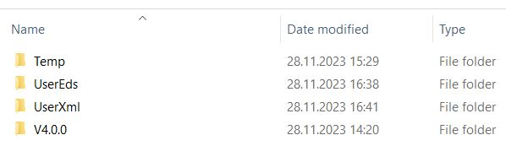
Figure 80: The UserEds directory
If an EDS file from the UserEds directory contains the same vendor ID and product ID as an EDS file that is already built into the TMCL-IDE then the EDS file from the UserEds directory will be used.
If no EDS file can be found for a device then only the Expert Mode tool can be used. All other CANopen tools of the TMCL-IDE will not be usable in such a case.

10.3 Device specific Tools
Depending on the connected module, different tools appear in the tool tree. The sections in this chapter describe each of these tools.

10.4 The Main Module Tool
Click on the module name itself in the tree view to open the main module tool. This provides some general information about the connected module as well as the possibility to send NMT commands to this module only.
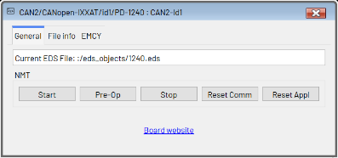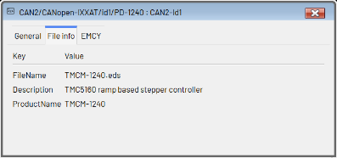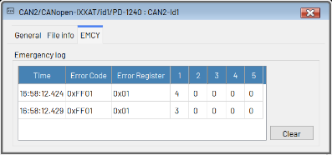
Figure 81: The Main Module Window

10.4.1 General
The General tab provides the name of the EDS file and NMT functions for this module:
- Start: Issues an NMT Start command for this module.
- Pre-Op: Issues an NMT Pre-Op command for this module.
- Stop: Issues an NMT Stop command for this module.
- Reset Comm: Issues an NMT Reset Communication command for this module.
- Reset Appl: Issues an NMT Reset Application command for this module.
The link to the board website provided here can only work correctly when the EDS file also contains the correct board website URL (which often is not the case).

10.4.2 File Info
The File Info tab contains some information from the EDS file. These are the EDS file name as contained by the EDS file, the product description and the product name.

10.4.3 EMCY
The EMCY tab contains a log of the CANopen emergency messages (EMCYs) produced by this device. For each EMCY a time stamp, the error code, the error register (object 1001h) and the five additional bytes are shown. Please note that the time stamp shown here may differ from the time stamp shown in the main log window by a few milliseconds. Use the Clear button to clear the emergency log. Explanations of the EMCY messages used by the individual device can be found in its CANopen firmware manual.

10.5 The Object Browser
The object browser is the main tool for reading and writing CANopen objects via SDO.
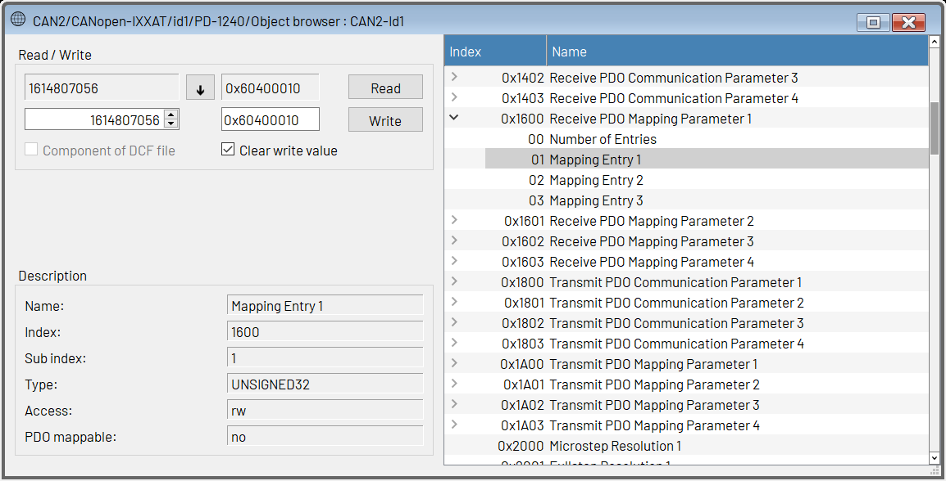
Figure 82: The Object Browser
On the right hand side of the object browser window, all objects contained by the EDS file are shown. Click on an object to select it. If an object contains sub indices, an arrow will be shown beneath the object entry. Click the arrow to open the object sub indices. Click on a sub index to select it.
Whenever an object or a sub index is selected, its content will be read and displayed on the upper left side of the window. Click the Read button to read it again. Numerical values will be shown as decimal numbers in the left display field and as hexadecimal values in the right display field. Clicking the button copies the contents of the display fields into the input fields. The left input field can only be used to enter decimal numbers, whereas the right input field serves for entering hexadecimal numbers (preceded by “0x” like in C language) or decimal numbers. Whenever one of these input fields gets changed, the other one will also be changed to the same value. Clicking the Write button writes the contents of the input field to the object. Objects that contain visible strings or octet strings are only shown in the right display field, and a new value can be entered also in the right input field only. Visible strings can be entered as text, and octet strings can be entered as hexadecimal bytes (two digits without preceding “0x”) separated by spaces. When the Clear write value option is checked the input fields will always be reset to zero when a new object has been selected.
Whenever an object has been written, the Component of DCF File checkbox will be checked. This means that when generating a DCF file using the Device Configuration tool the last entered value of this object will also be written to the DCF file. Uncheck this checkbox if the object is not to be written to the DCF file. You do not have to care about this checkbox when not using DCF file generation.
The object browser also shows some information about the selected object:
- Name: The name of the object.
- Index: The index of the object as a hexadecimal value.
- Sub index: The sub index of the object as a decimal value.
- Type: The data type of the object.
- Access: The access type of the object.
- PDO mappable: Shows if the object can be mapped to PDOs.

10.6 CiA-402 State Machine
With motion control modules that use the CiA-402 profile, the CiA-402 state machine tool can be used.
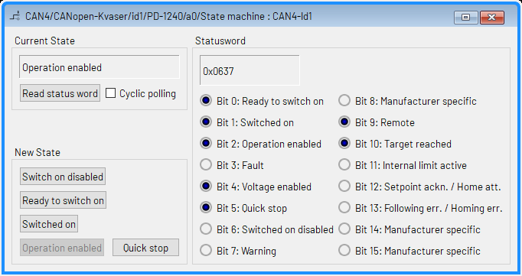
Figure 83: The CiA-402 State Machine Tool
Its window is divided into three sections:
- Current State: In this section the current state of the state machine is shown. Click the Read status word button to update the current state display. When the Cyclic polling checkbox is checked the current state display will be updated on a regular base, by polling the status word via SDO.
- Statusword: Here, the statusword is shown as a hexadecimal value. Also the single bits of the status-word are shown with their meanings.
- New State: Use the buttons provided here to switch to a different state. The current state and status word display will be updated automatically afterwards.

10.7 CiA-402 Profile Position Mode
With motion control modules that support the CiA-402 profile position (pp) mode, the CiA-402 profile position mode tool can be used.
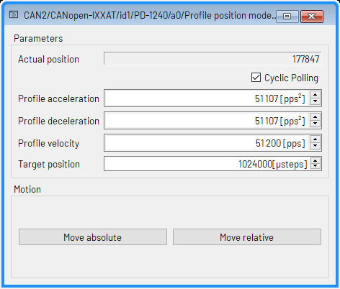
Figure 84: The CiA-402 Profile Position Mode Tool
In the Parameters section the acceleration, deceleration, velocity and target position can be set. When the Cyclic Polling checkbox is checked the actual position display will be updated on a regular base, by polling the actual position object via SDO.
Click the Move absolute or the Move relative button to start the motion.

10.8 CiA-402 Profile Velocity Mode
With motion control modules that support the CiA-402 profile velocity (pv) mode, the CiA-402 profile velocity mode tool can be used.
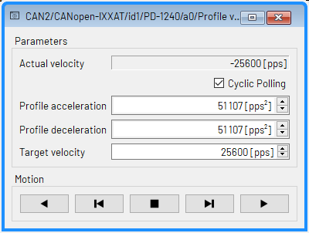
Figure 85: The CiA-402 Profile Velocity Mode Tool
In the Parameters section the acceleration, deceleration, and target velocity can be set. When the Cyclic Polling checkbox is checked the actual velocity display will be updated on a regular base, by polling the actual velocity object via SDO.
Use the arrow buttons in the Motion section to control the motor:
- The motor continues running in negative direction until clicking the stop button or a different button for running the motor.
- The motor runs in negative direction as long as the button is being pressed. When releasing the button the motor will be stopped.
- Stop: clicking this button will stop the motor.
- The motor runs in positive direction as long as the button is being pressed. When releasing the button the motor will be stopped.
- The motor continues running in positive direction until clicking the stop button or a different button for running the motor.

10.9 CiA-402 Homing Mode
With motion control modules that support the CiA-402 homing (hm) mode, the CiA-402 homing mode tool can be used.
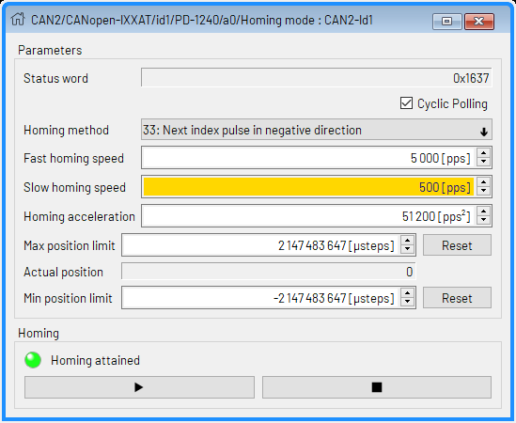
Figure 86: The CiA-402 Homing Mode Tool
In the Parameters section the homing method, homing speeds and homing acceleration can be set. The software position limits can also be changed here. When the Cyclic Polling checkbox is checked the status word display will be updated on a regular base, by polling the status word object via SDO.
Use the buttons in the Homing section to start or to interrupt the homing. The homing attained flag of the status word is also shown here.

10.10 Parameter Save/Restore
This tool can be used with all devices that support saving parameters to non-volatile memory.
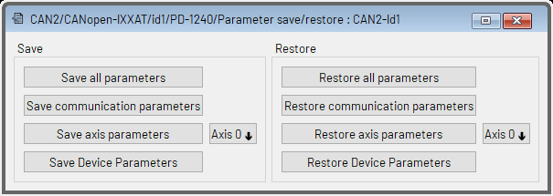
Figure 87: The Parameter Save/Restore Tool
Using this tool, the parameter save/restore functions of a device can be used easily, without having to remember the CANopen save and load signatures. The tool provides the following functions:
- Save all parameters: Writes the save signature to object 1010 h sub-index 1 in order to save all parameters.
- Save communication parameters: Writes the save signature to object 1010h sub-index 2 in order to save just the communication parameters.
- Save axis parameters: Writes the save signature to object 1010 h sub-index 4 (or on multi-axis modules: 4 + axis _number) in order to save just the parameters of the selected axis.
- Save device parameters: Writes the save signature to object 1010h sub-index 5 (or on multi-axis modules: 4 + number_of_motors) in order to save just the device related parameters (configuration of general purpose I/O ports for example).
- Restore all parameters: Writes the load signature to object 1011h sub-index 1 in order to restore all parameters to their default settings.
- Restore communication parameters: Writes the load signature to object 1011 h sub-index 2 in order to restore just the communication parameters to their default settings.
- Restore axis parameters: Writes the load signature to object 1011h sub-index 4 (or on multi-axis modules: 4 + axis_number) in order to restore just the parameters of the selected axis to their factory default settings.
- Restore device parameters: Writes the load signature to object 1011h sub-index 5 (or on multi-axis modules: 4 + number_of_motors) in order to restore just the device related parameters.

10.11 PDO Receiver
The PDO Receiver tool displays the contents of PDOs sent out by the device (TPDOs). When opened for the first time, the PDO Receiver tool reads out all TPDO definitions from the device in order to be able to display the PDO contents correctly. Click on the arrow beneath a TPDO entry to view its contents. The display will be updated each time such a PDO has been sent out by the device and reaches the PDO Receiver tool. Inactive TPDOs are displayed in gray color. The PDO contents are shown with the object index (hexadecimal), the object sub-index (decimal) and the contents of that object. It is also possible to select PDO entries to be displayed in a graphical way. If this is selected the entry will be displayed in italic letters. The color of each PDO entry can also be individually selected.
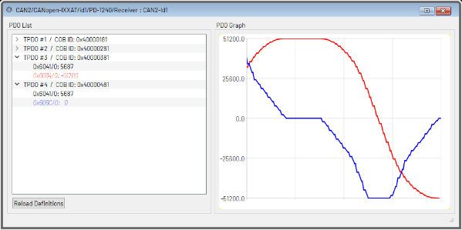
Figure 88: The PDO Receiver Tool
Double click on the displayed contents in order to change between decimal and hexadecimal value representation of the content. Clicking the right mouse button over a PDO entry brings up a context menu. In this menu, hexadecimal or decimal value representation can also be selected and the PDO entry can be added to the graphical view.
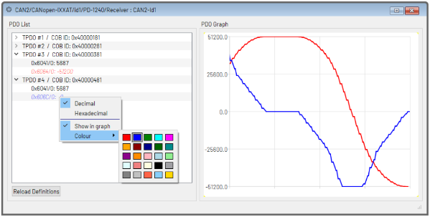
Figure 89: The PDO Entry Context Menu
The PDO entry context menu offers the following functions:
- Decimal: Selects decimal value representation (same function as double clicking the value).
- Hexadecimal: Selects hexadecimal value representation (same function as double clicking the value).
- Show in graph: Selects (or deselects) the PDO entry to be displayed in the graphical view.
- Color: Selects the color used for the graphical view. The numerical value will also take that color.
Clicking the right mouse button over the graphical view brings up the PDO graph context menu.
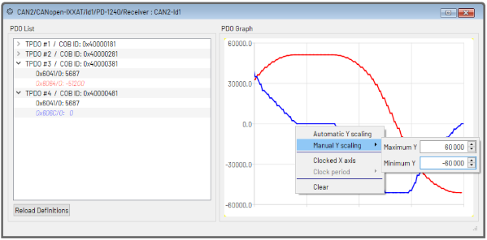
Figure 90: The PDO Graph Context Menu
This context menu offers the following functions:
- Automatic Y scaling: Selects automatic Y scaling (default setting). The range of the Y scale is automatically set so that all displayed curves will fit into the graph. Turning off this option will select manual Y scaling.
- Manual Y scaling: When automatic Y scaling is turned off, the Y range can be entered here.
- Clocked X axis: Selects if the X axis shall be continued using an internal timer (turned off by default). This can be useful when event triggered PDOs are to be displayed. For time triggered PDOs or synchronized PDOs it is mostly better to turn off this feature.
- Clock period: When clocked X axis is turned on the clock period can be entered here.
- Clear: Clears the entire graph.
If the PDO definitions have been changed on the device, click the Reload Definitions button. The tool will then read all TPDO definitions from the device once again. Please note that this will also reset all settings for the graphical view.

10.12 PDO Transmitter
Using the PDO Transmitter tool, PDOs can be sent to each connected device in an easy and convenient way. When opened for the first time, the PDO Transmitter tool reads out all RPDO definitions from the device. All RPDOs are shown in the PDO Selector area on the left hand side of the window. Click on an RPDO to select that one. Inactive RPDOs are shown in gray color and cannot be selected. After an RPDO has been selected, all the objects mapped to that PDO are shown in the PDO Data area on the right hand side of the window. For each object the desired value can be entered, either as a decimal number or as a hexadecimal number (starting with “0x” like in C language). After having entered a value for each of the mapped objects, click the Send PDO button to send out the PDO.
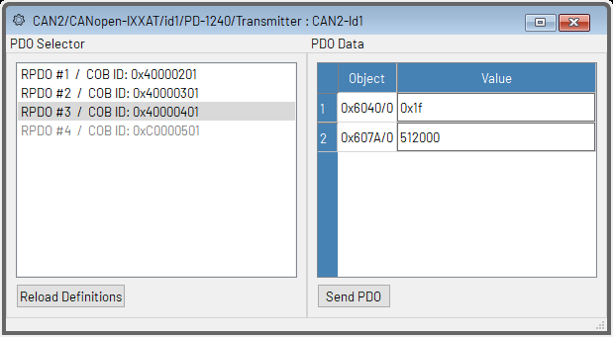
Figure 91: The PDO Transmitter Tool
If the PDO definitions have been changed on the device, click the Reload Definitions button. The tool will then read all RPDO definitions from the device once again.

10.13 PDO Configurator
The PDO Configurator is a tool for easily changing all PDO definitions of a device. When opened for the first time, the PDO Configurator tool reads all RPDO definitions and all TPDO definitions from the device. The window is divided into an RPDO tab and a TPDO tab.
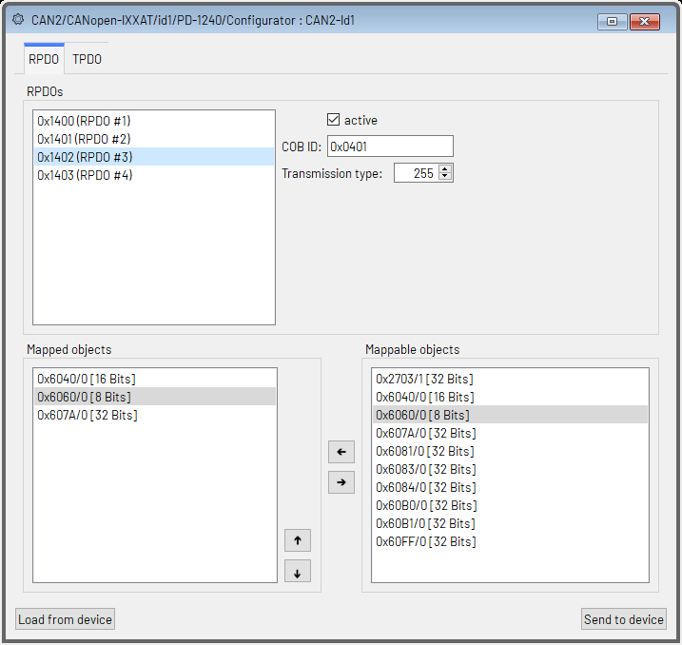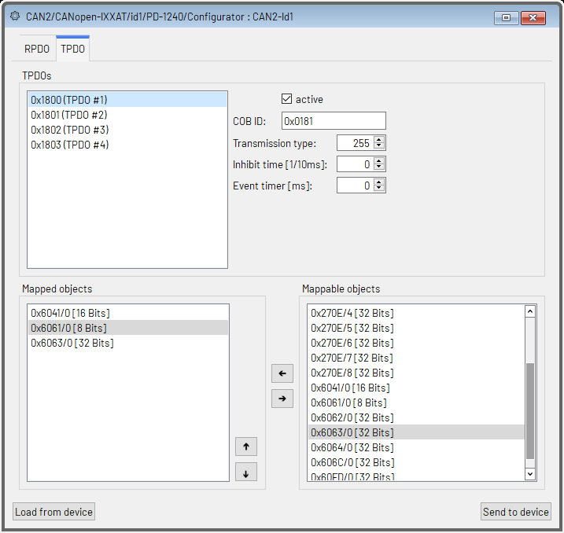
Figure 92: The PDO Configurator Tool
Use the RPDO tab to view and to edit the RPDO definitions. In the upper area of the RPDO tab, all RPDOs supported by the device are shown. Select an RPDO from the list to view and to edit it. Beside the RPDO list, all communication settings of the selected RPDO are shown and can be changed:
- Active: use this checkbox to activate or deactivate the selected RPDO (this will internally change bit 31 of its COB-ID).
- COB-ID: this is the COB-ID of the selected RPDO. Only the lower 11 bits are shown and can be set here.
- Transmission type: the transmission type of the selected RPDO.
The lower area of the RPDO tab presents two lists: one on the left side that shows all objects that are currently mapped to the selected RPDO (Mapped objects) and one that shows all objects that can be mapped to RPDOs (Mappable objects). To map an object to the selected RPDO, select the desired object from the list of mappable objects. Then click the left arrow button or double click the object. The object will then appear also on the list of mapped objects. Please note that the object will not be removed from the list of mappable objects, as each object can also be mapped more than once. To remove an object from the selected RPDO, select it in the list of mapped objects and click the right arrow button or double click the object. It will then be removed from the list of mapped objects. Use the up and down arrow buttons for changing the order of the mapped objects in the list. The currently selected object in the list of mapped objects can be moved up or down using these two buttons.
Use the TPDO tab to view and to edit the TPDO definitions. In the upper area of the TPDO tab, all TPDOs supported by the device are shown. Select a TPDO from the list to view and to edit it. Beside the TPDO list, all communication settings of the selected TPDO are shown and can be changed:
- Active: use this checkbox to activate or to deactivate the selected TPDO (this will internally change bit 31 of its COB-ID).
- COB-ID: this is the COB-ID of the selected TPDO. Only the lower 11 bits are shown and can be set here.
- Transmission type: the transmission type of the selected TPDO.
- Inhibit time: the inhibit time of the selected TPDO (given in 1/10ms).
- Event timer: the event timer of the selected TPDO (given in ms). Please bear in mind that the transmission type must be set to 254 or to 255 in order to be able to use an event timer value greater than zero.
The lower area of the TPDO tab presents two lists: one on the left side that shows all objects that are currently mapped to the selected TPDO (Mapped objects) and one that shows all objects that can be mapped to TPDOs (Mappable objects). To map an object to the selected TPDO, select the desired object from the list of mappable objects. Then click the left arrow button or double click the object. The object will then appear also on the list of mapped objects. Please note that the object will not be removed from the list of mappable objects, as each object can also be mapped more than once. To remove an object mapping from the selected TPDO, select it in the list of mapped objects and click the right arrow button or double click the object. It will then be removed from the list of mapped objects. Use the up and down arrow buttons for changing the order of the mapped objects in the list. The currently selected object in the list of mapped objects can be moved up or down using these two buttons.
After having made all necessary changes, click the Send to device button to send all changed PDO communication parameters and mappings to the device. Please note that only those parameters that have been changed will be sent to the device. During this step, all values sent are also written into the internal DCF file buffer, so that after this step the new values can also be saved to a DCF file (using the Device Configuration tool).
The Load from device button reloads all PDO definitions from the device. Use this function with care, as all changes made in the PDO Configurator which have not yet been sent to the device will be lost by reloading the PDO definitions from the device.

10.14 Device Configuration
Using the Device Configuration tool, DCF files (according to the CiA-305 standard) can be generated, and DCF files can be used to configure devices.

10.14.1 Generating DCF Files
The DCF Generation tab page is used to generate DCF files. All necessary information according to the CiA-305 standard can be entered in the File Description and Device Commissioning section of this tab page. This information will be written to the DCF file, without being further processed by the TMCL-IDE. When writing values to CANopen objects using the Object Browser or the PDO Configurator, the last written value will always be written to an internal buffer. When generating a DCF file, all these last written values will also be written to the DCF file. If an object value is not to be written to the DCF file, uncheck its Component of DCF file checkbox in the Object Browser or uncheck its DCF Use checkbox in the DCF Values tab in this tool before generating the DCF file. Clicking the Generate DCF File button will start the DCF file generation.
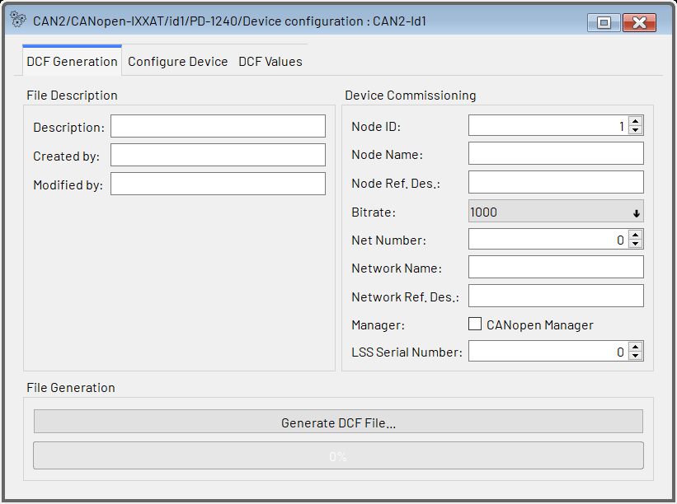
Figure 93: DCF File Generation
So the following procedure can be used to generate a DCF file:
- Use the Object Browser to write the desired value to each object that is to be saved in the DCF file. Should you have written a wrong value, just write a new value to that object. If you wish not to save that object value in the DCF file at all, uncheck the Component of DCF file checkbox. Objects changed using the PDO Configurator will also be marked to be saved in the DCF file.
- Open the Device Configuration tool and enter all necessary file information and device commissioning information.
- Click the Generate DCF File button in the Device Configuration tool to generate the DCF file.

10.14.2 Using DCF Files
For using a DCF file to configure a module, select the Configure Device tab page of the Device Configuration tool.
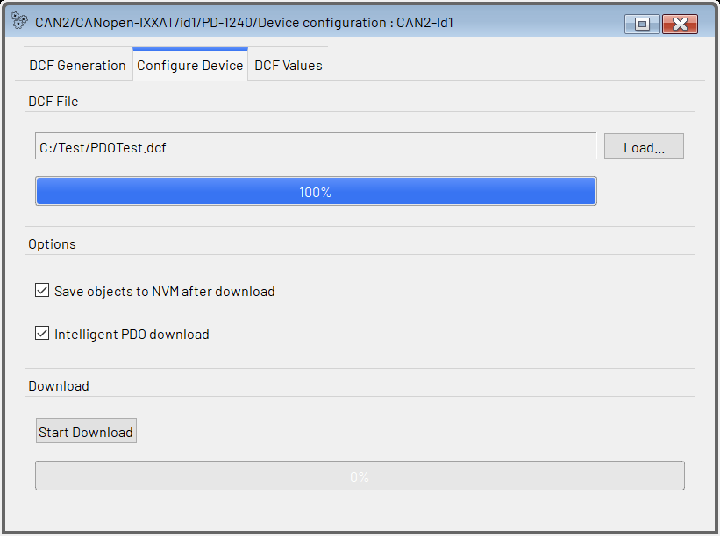
Figure 94: DCF File Usage
Click the Load button to load a DCF file. Set the options as necessary:
- Save objects to NVM after download: All objects will be saved to non volatile memory after download (if the device supports this). This is achieved by writing the save signature to object 1010h sub-index 1 after the download of all objects contained by the DCF file has completed.
- Intelligent PDO download: When this option is selected, PDO definition objects contained by the DCF file will be downloaded in such a way that PDO definitions will work correctly. If this option is not selected, all objects contained by the DCF file will be downloaded in numerical order. In most cases, this option should be switched on, so normally leave this checked.
Click the Start Download button to start the download of the values contained by the DCF file.

10.14.3 DCF Value Overview
The DCF Values tab contains an overview of all objects and their values that are to be stored in the DCF file or that have been loaded from the DCF file.
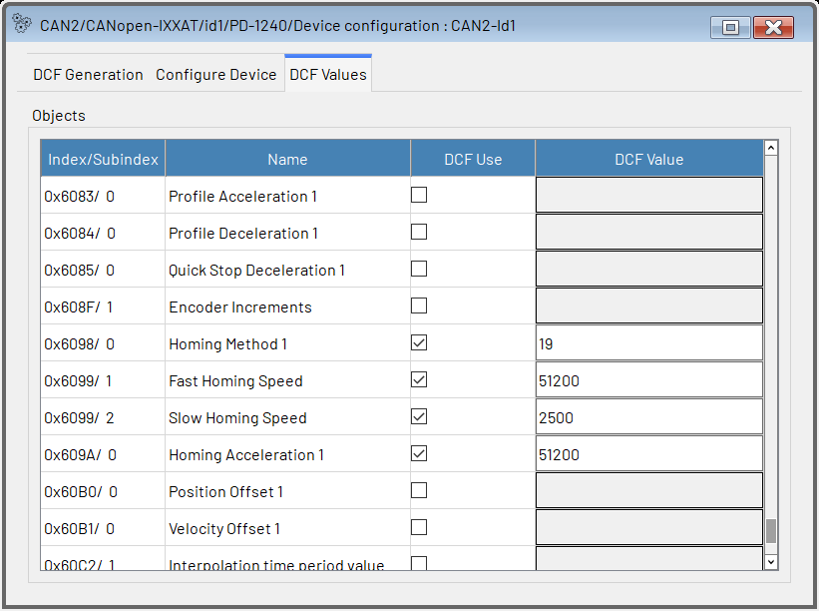
Figure 95: DCF Value Overview
The checkbox in the DCF Use column shows if the DCF value of an object will be stored in the DCF file or will be sent to the device when configuring it. The DCF Value column shows the value that is used in the DCF file. The DCF flag and the DCF value can also be changed here before saving the DCF file or before configuring the device.
It is also possible to make changes here after a DCF file has been loaded. This way, the device configuration tool can also be used as a simple DCF file editor.

10.15 Import/Export
The Import/Export tool is an easier way of generating and using DCF files (according to the CiA-305 standard) for exporting and importing the configuration of a CANopen device. In contrast to the Device Configuration tool, it always saves the values of all writable objects in the DCF file that it generates.

10.15.1 Generating DCF Files
To generate a DCF file using this tool, first fill in the Description, Created by and Modified by fields with meaningful values. These will be saved into the DCF file without further processing. Then, click the Export to DCF button and select where to save the DCF file. The tool then reads all writable objects from the device and saves their contents to the DCF file. Only objects where the Refuse Read on Scan flag is set in the EDS file will not be saved.
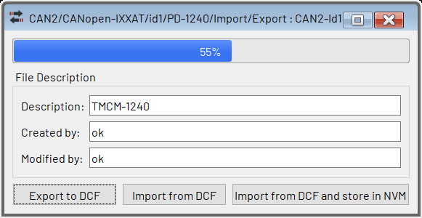
Figure 96: DCF File Generation
The generated DCF file can then be used either with the import functions of this tool or with the Device Configuration tool or also with configuration tools from other vendors.

10.15.2 Using DCF Files
To use a DCF file (either generated by this tool or by other tools), either click the Import from DCF button or click the Import from DCF and save to NVM button. The tool then loads the DCF file and sets all object values to those loaded from the file. When using the Import from DCF and save to NVM button, all values are additionally stored to the NVM of the module using object 1010h sub-index 1.

10.16 Expert Mode
The Expert Mode tool can be used to directly access CANopen objects on a device, without needing the information contained in the EDS file. This can be necessary either if there is no EDS file for the connected device or if objects are to be accessed that are not contained in the EDS file (for example when developing a new device).
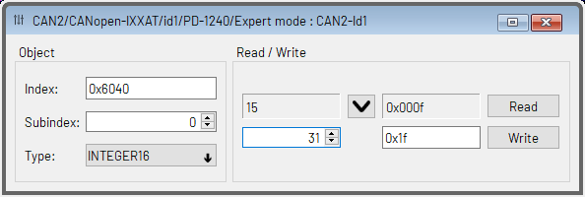
Figure 97: The Expert Mode
In the Object section on the left hand side of the window, the object index and sub-index can be entered. Also, the object type can be selected. When reading from an object the tool will try to automatically recognize the object type (even if there is an EDS file this tool will not use the information from it). Click the Read button in the Read / Write area of the window to read the data from the object. The data will be shown as a decimal value in the left display field and as a hexadecimal value in the right display field. Clicking the button will copy the contents of the display fields into the input fields. In the left input field, data can be entered as a decimal value only, whereas in the right input field either hexadecimal or decimal numbers can be entered. Whenever one of these input fields gets changed, the other one will also be changed to the same value. When the data type VISIBLE STRING or OCTET STRING is selected, only the right display field and the right input field will be used. In such cases, visible strings can be entered as text, and octet strings can be entered as hexadecimal bytes (two digits without preceding “0x”) separated by spaces.
Clicking the Write button will write the data to the object.

10.17 Velocity Graph
The Velocity Graph tool is the same tool as the TMCL Velocity Graph. It works just the same way as the TMCL Velocity Graph, but works with CANopen objects instead of TMCL parameters. Instead of TMCL parameters, CANopen objects can be selected to be displayed in the graph. The selected objects will be polled regularly as SDOs.

10.18 Position Graph
The Position Graph tool is the same tool as the TMCL Position Graph. It works just the same way as the TMCL Position Graph, but works with CANopen objects instead of TMCL parameters. Instead of TMCL parameters, CANopen objects can be selected to be displayed in the graph. The selected objects will be polled regularly as SDOs.

10.19 Torque Graph
The Torque Graph tool is the same tool as the TMCL Torque Graph. It works just the same way as the TMCL Torque Graph, but works with CANopen objects instead of TMCL parameters. Instead of TMCL parameters, CANopen objects can be selected to be displayed in the graph. The selected objects will be polled regularly as SDOs. The Torque Graph is only available with modules that support a torque mode (BLDC modules and closed loop stepper motor modules).

10.20 Parameter Display
The Parameter Display tool is the same tool as the TMCL Parameter Display. It works the same way. The only difference is that it works with CANopen objects instead of TMCL parameters. Instead of TMCL parameters, CANopen objects can be selected to be displayed. The selected objects will be polled regularly as SDOs.

11 Figures Index
Figure 1: The TMCL-IDE Main Window 5
Figure 2: The Menu an Status Bar 5
Figure 3: The Menu Bar’s entries 5
Figure 4: The TMCL-IDE About Box 5
Figure 5: The TMCL-IDE Tool Bar 6
Figure 6: Tree with Connected Devices and their Tools 6
Figure 7: The TMCL-IDE Main Window with user layout 6
Figure 8: The USB Connection Window 7
Figure 9: The Serial Port Connection Window 8
Figure 10: The CAN Bus Connection Window 9
Figure 11: The Main Module Tool 11
Figure 12: The Direct Mode Tool 11
Figure 13: The Direct Mode Tool (extended) 11
Figure 14 The Global Parameters Tool 12
Figure 15 The TMCL Creator 12
Figure 16 The Editor Settings Dialog 13
Figure 17: Progress of the Assembly 13
Figure 18: TMCL Program Download 13
Figure 19: Program Disassembly 14
Figure 20: Assembler/Debugger Options 14
Figure 21: The TMCL Creator in Debug Mode 15
Figure 22: The Settings Export/Import Tool 16
Figure 23: The Parameter Calculator for TMC429 based Stepper Motor Modules 17
Figure 24: The Parameter Calculator for all other Stepper Motor Modules 17
Figure 25: The User Variable Display 18
Figure 26: Different Appearances of the Settings Tool 18
Figure 27: The Different Tabs of the Closed Loop Tool 18
Figure 28: The TMCL Tab of the Closed Loop Tool 18
Figure 29: Chopper Settings — Thresholds 19
Figure 30: Chopper Settings — StealthChop 19
Figure 31: Chopper Settings — SpreadCycle 20
Figure 32: Chopper Settings — High Speed 20
Figure 33: Chopper Settings — TMCL 20
Figure 34: The Velocity Graph 21
Figure 35: The Parameter Selection Dialog 21
Figure 36: Graph Scaling Options 21
Figure 37: The Position Graph 22
Figure 38: The Torque Graph 22
Figure 39: Different Appearances of the Velocity Mode Tool 22
Figure 40: Different Appearances of the Position Mode Tool 23
Figure 41: The Torque Mode for Stepper Motors 23
Figure 42: The Torque Mode for BLDC Motors 24
Figure 43: The Axis Parameter Display 24
Figure 44: The StallGuard Adjuster 24
Figure 45: The StallGuard Profiler 25
Figure 46: The CoolStep & StallGuard2 Tool 26
Figure 47: The CoolStep Tab 27
Figure 48: The TMCL Tab 27
Figure 49: The BLDC Motor Settings Tool 28
Figure 50: The BLDC Motor Flags Tool 28
Figure 51: The Parameter Display 29
Figure 52: The Parameter Browser 29
Figure 53: Torque tuning tool overview 30
Figure 54: Automatic torque/flux tuning 30
Figure 55: Manual torque/flux tuning 30
Figure 56: Velocity tuning tool overview 31
Figure 57: Automatic Velocity tuning 31
Figure 58: Manual Velocity tuning 31
Figure 59: Position tuning tool overview 32
Figure 60: Automatic Position tuning 32
Figure 61: Manual Position tuning 32
Figure 62: The Main Evaluation Board Tool 33
Figure 63: The Register Browser 33
Figure 64: Changing a Register Value 34
Figure 65: The Flags View 34
Figure 66: The Chip-Click Tool 35
Figure 67: The Datagram Mode Tool 35
Figure 68: The TMCL/PC Host 36
Figure 69: The Editor Settings Dialog 36
Figure 70: Progress of the TMCL/PC Assembly 37
Figure 71: The TMCL/PC Options Dialog 37
Figure 72: The Module Assignments Dialog 38
Figure 73: The Local Variables Window 38
Figure 74: The Firmware Update Tool 39
Figure 75: The Wizard Window 40
Figure 76: The CANopen Connection Window 45
Figure 77: The LSS tab (with empty LSS device list) 46
Figure 78: The LSS device list contains two LSS devices and showing its context menu 46
Figure 79: The Trace tab 47
Figure 80: The UserEds directory 47
Figure 81: The Main Module Window 47
Figure 82: The Object Browser 48
Figure 83: The CiA-402 State Machine Tool 49
Figure 84: The CiA-402 Profile Position Mode Tool 49
Figure 85: The CiA-402 Profile Velocity Mode Tool 50
Figure 86: The CiA-402 Homing Mode Tool 50
Figure 87: The Parameter Save/Restore Tool 50
Figure 88: The PDO Receiver Tool 51
Figure 89: The PDO Entry Context Menu 51
Figure 90: The PDO Graph Context Menu 52
Figure 91: The PDO Transmitter Tool 52
Figure 92: The PDO Configurator Tool 53
Figure 93: DCF File Generation 54
Figure 94: DCF File Usage 54
Figure 95: DCF Value Overview 55
Figure 96: DCF File Generation 55
Figure 97: The Expert Mode 55

12 Tables Index
Table 1: List of supported CAN Interfaces (Windows) 9
Table 2: List of supported CAN Interfaces (Linux) 9
Table 3: Functions in Constant Expressions 41
Table 4: Operators in Constant Expressions 42
Table 5: Software Revision 59
Table 6: Document Revision 59

13 Supplemental Directives

13.1 Producer Information

13.2 Copyright
ADI Trinamic/Trinamic Motion Control GmbH & Co. KG owns the content of this user manual in its entirety, including but not limited to pictures, logos, trademarks, and resources.
Redistribution of sources or derived formats (for example, Portable Document Format or Hypertext Markup Language) must retain the above copyright notice, and the complete data sheet, user manual, and documentation of this product including associated application notes; and a reference to other available product-related documentation.

13.3 Trademark Designations and Symbols
Trademark designations and symbols used in this documentation indicate that a product or feature is owned and registered as trademark and/or patent either by ADI Trinamic or by other manufacturers, whose products are used or referred to in combination with ADI Trinamic’s products and ADI Trinamic’s product documentation.
This PC Software is a non-commercial publication that seeks to provide concise scientific and technical user information to the target user. Thus, trademark designations and symbols are only entered in the Short Spec of this document that introduces the product at a quick glance. The trademark designation /symbol is also entered when the product or feature name occurs for the first time in the document. All trademarks and brand names used are property of their respective owners.

13.4 Target User
The documentation provided here, is for programmers and engineers only, who are equipped with the necessary skills and have been trained to work with this type of product.
The Target User knows how to responsibly make use of this product without causing harm to himself or others, and without causing damage to systems or devices, in which the user incorporates the product.

13.5 Disclaimer: Life Support Systems
ADI Trinamic/Trinamic Motion Control GmbH & Co. KG does not authorize or warrant any of its products for use in life support systems, without the specific written consent of ADI Trinamic/Trinamic Motion Control GmbH & Co. KG.
Life support systems are equipment intended to support or sustain life, and whose failure to perform, when properly used in accordance with instructions provided, can be reasonably expected to result in personal injury or death.
Information given in this document is believed to be accurate and reliable. However, no responsibility is assumed for the consequences of its use nor for any infringement of patents or other rights of third parties which may result from its use. Specifications are subject to change without notice.

13.6 Disclaimer: Intended Use
The data specified in this user manual is intended solely for the purpose of product description. No representations or warranties, either express or implied, of merchantability, fitness for a particular purpose or of any other nature are made hereunder with respect to information/specification or the products to which information refers and no guarantee with respect to compliance to the intended use is given.
In particular, this also applies to the stated possible applications or areas of applications of the product. TRINAMIC products are not designed for and must not be used in connection with any applications where the failure of such products would reasonably be expected to result in significant personal injury or death (safety-Critical Applications) without ADI Trinamic’s/Trinamic Motion Control GmbH & Co. KG specific writ-ten consent.
ADI Trinamic/Trinamic Motion Control GmbH & Co. KG products are not designed nor intended for use in military or aerospace applications or environments or in automotive applications unless specifically designated for such use by ADI Trinamic/Trinamic Motion Control GmbH & Co. KG. ADI Trinamic/Trinamic Motion Control GmbH & Co. KG conveys no patent, copyright, mask work right or other trademark right to this product. ADI Trinamic/Trinamic Motion Control GmbH & Co. KG assumes no liability for any patent and/or other trademark rights of a third party resulting from processing or handling of the product and/or any other use of the product.

13.7 Collateral Documents and Tools
This product documentation is related and/or associated with additional tool kits, firmware and other items, as provided on the product page at: www.analog.com.

14 Revision History

14.1 Software Revision
Version | Date | Description
V4.2.0 | 01/24 | Release version (including also CANopen).
V4.2.2 | 03/24 | CANopen: new import/export tool.
V4.3.0 | 04/24 | CANopen: DCF value overview in device configuration tool.
V4.4.0 | 08/24
V4.5.0 | 11/24 | CANopen also supported for Linux.
V4.6.0 | 12/24 | Support for TMC9660.
Table 5: Software Revision

14.2 Document Revision
Version | Date | Description
V4.00 | 02/24 | CANopen part also included. Release for TMCL-IDE V4.2.0
V4.01 | 03/24 | CANopen: Import/Export tool included. Release for TMCL-IDE V4.2.2
V4.02 | 04/24 | CANopen device configuration tool: DCF value overview included. Release for TMCL-IDE V4.3.0
V4.03 | 12/24 | Parameter Browser included. Release for TMCL-IDE V4.6.0
Table 6: Document Revision

